

Weather Information in XML
Version 3.0

Schema Specification

2021

© The Government of the Hong Kong Special Administrative Region

The contents of this document remain the property of, and may not be reproduced in whole or in part without the express permission of the Government of the HKSAR
Table of Contents
1 Introduction 4
2 Bulletin Descriptions 4
3 Schema Application 6
3.1 Design Overview 6
3.2 Information Sub-components 7
3.2.1 Altitude Information 7
3.2.2 Reading 8
3.3 Information Components 9
3.3.1 Temperature Information 9
3.3.2 Relative Humidity Information 11
3.3.3 Wind Information 12
3.3.4 Rainfall Information 14
3.3.5 Sunshine Information 15
3.3.6 Ultraviolet Information 16
3.3.7 Radiation Information 17
3.3.8 Pressure Information 19
3.3.9 Visibility Information 20
3.3.10 Sea Situation Information 21
3.3.11 Tropical Cyclone Information 22
3.3.12 Sea Wave Information 23
3.3.13 Swell Information 25
3.3.14 Solar Lunar Information 26
3.3.15 Tidal Information 27
3.3.16 Time Range 29
3.3.17 Weather Icon 31
3.3.18 PSR 32
3.4 Components in Bulletin 33
3.4.1 Bulletin Header 33
3.4.2 Location 35
3.4.3 Special Announcement 38
3.4.4 Special Weather Tip 39
3.4.5 Warning Info 40
3.4.6 Tropical Cyclone Info 41
3.4.7 Lightning Info 42
Weather Forecast 43
3.4.8 Weather Report 48
3.4.9 Weather Announcement 53
Name 53
3.4.10 Weather Warning 55
3.4.11 Astronomical Information 57
3.4.12 Information Source 59
3.4.13 Tsunami Information 60
3.4.14 Tsunami Warning 61
4 Bulletin 62
4.1.1 Weather Bulletin 62
4.1.2 Weather Forecast 66
4.1.3 Weather Report 88
4.1.4 Weather Announcement and Warning 106
4.1.5 Astronomical Information 111
4.1.6 Tsunami Warning and Information 113

- Introduction
This document provides the XML schema definitions and structure for XML documents which aim at facilitating the exchange of weather information by electronic means.

This document aims to provide the following information:
- Introduction of the bulletins which are the fundamentals of the XML schema.
- Definition of the elements and the constraints imposed on them explaining how the data should be interpreted.

The design of this XML schema has adopted the Business Information Modelling methodology of the XML Schema Design and Management Guide. Please refer to http://www.ogcio.gov.hk/eng/infra/eif.htm#if_spec for more information.

- Bulletin Descriptions
This XML schema was constructed to provide information of the following bulletins which fall into four main categories:
- Weather Forecast
  - Several Days Weather Forecast
  - Local Weather Forecast
  - City Weather Forecast
- Weather Report
  - Current Weather
  - Regional Weather
  - Yesterday Weather
  - South China Coastal Waters
  - Hong Kong Waters
  - Tropical Cyclone Bulletin
- Weather Warning and Announcement
  - Weather Announcement Bulletin
  - Weather Warning Bulletin
  - Weather Warning Summary
- Astronomical Information
  - Astronomical Information Bulletin
- Tsunami Warning and Information
  - Tsunami Warning Bulletin
  - Tsunami Information Bulletin

Besides the above bulletins, the XML schema may also be exploited to construct a “Weather Bulletin” which may include weather forecast, weather report, weather announcement and warning.

There are seven main components of the XML schema. Each XML document issued by the (HKO) includes one or more of these components. The components are listed below:
- Weather Forecast
- Weather Report
- Weather Announcement
- Weather Warning
- Tsunami Warning
- Tsunami Information
- Astronomical Information

- For example, the “Current Weather” XML document comprises “Weather Report” elements, while the “Weather Warning Summary” XML document comprises “Weather Warning” elements.

The detailed structures of the bulletins will be introduced next.

- Schema Application
This section provides constraints on the element paths of the XML schema and their definition in a bottom-up approach.

  - Design Overview
The following diagram illustrates the overview structure of the XML schema.
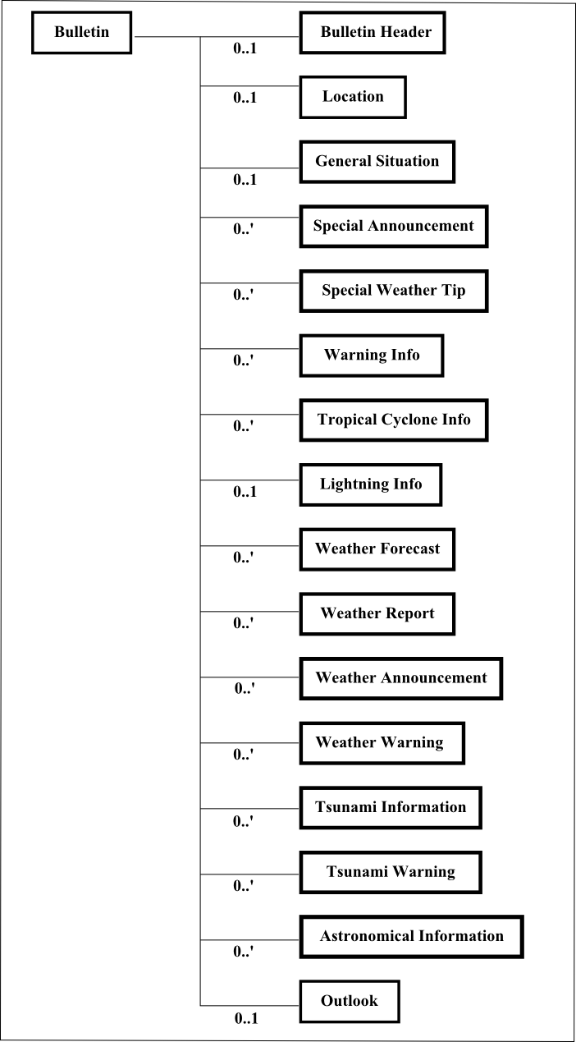
  - Information Sub-components
    - Altitude Information
Name | AltitudeInformation. Type
Definition | Information related to altitude.
Structure | 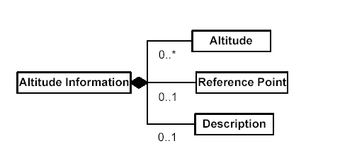

      - Child Elements
Name | Altitude
Definition | Measurement of altitude.
Type | Reading. Type
Occurrence | 0-*

Name | ReferencePoint
Definition | Point above which the altitude is measured.
Type | Code. Type
Occurrence | 0-1

Name | Description
Definition | Textual statement describing or related to the altitude.
Type | Text. Type
Occurrence | 0-1 | Max. Length | 210

Example
<AltitudeInformation>
<Altitude>
<Measure unitCode="ZZ">0</Measure>
<UnitCode>MTR</UnitCode>
</Altitude>
<ReferencePoint>S</ReferencePoint>
</AltitudeInformation>

    - Reading
Name | Reading. Type
Definition | Reading includes the measurement with the unit code and the unit name.
Structure | 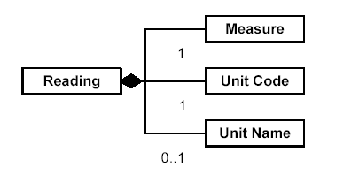

      - Child Elements
Name | Measure
Definition | Measure with optionally its unit.
Type | Measure. Type
Occurrence | 1

Name | UnitCode
Definition | The measuring unit code of the reading if it is not defined in UN/ECE Rec. 20.
Type | Code. Type
Occurrence | 1

Name | UnitName
Definition | The measuring unit name of the reading if it is not defined in UN/ECE Rec. 20.
Type | Text. Type
Occurrence | 0-1 | Max. Length | 70

Example
<Reading>
<Measure unitCode="ZZ">9</Measure>
<UnitCode>CEL</UnitCode>
<UnitName>Degree Celsius</UnitName>
</Reading>

  - Information Components
    - Temperature Information
Name | TemperatureInformation. Type
Definition | Information related to temperature at a particular environment.
Structure | 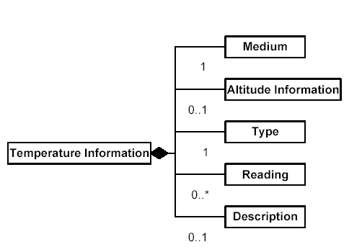

      - Child Elements
Name | Medium
Definition | Substance in which the temperature information is referring to.
Type | Code. Type
Occurrence | 1

Name | AltitudeInformation
Definition | Information on altitude specifying the environment at which the temperature information is referring to.
Type | AltitudeInformation. Type
Occurrence | 0-1

Name | Type
Definition | Type of temperature information.
Type | Code. Type
Occurrence | 1

Name | Reading
Definition | Measurement of temperature.
Type | Reading. Type
Occurrence | 0-*

Name | Description
Definition | Textual statement describing or related to the temperature at the particular environment.
Type | Text. Type
Occurrence | 0-1 | Max. Length | 210

Example
<TemperatureInformation>
<Medium>O</Medium>
<AltitudeInformation>
<Altitude>
<Measure unitCode="ZZ">-1.0</Measure>
<UnitCode>MTR</UnitCode>
</Altitude>
<ReferencePoint>G</ReferencePoint>
</AltitudeInformation>
<Type>N</Type>
<Reading>
<Measure unitCode="ZZ">20.4</Measure>
<UnitCode>CEL</UnitCode>
</Reading>
<Description>Derived from incomplete data set.</Description>
</TemperatureInformation>

    - Relative Humidity Information
Name | RelativeHumidityInformation. Type
Definition | Information related to relative humidity at a particular environment.
Structure | 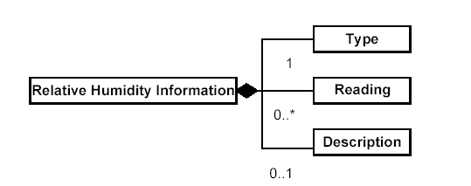

      - Child Elements
Name | Type
Definition | Type of relative humidity information.
Type | Code. Type
Occurrence | 1

Name | Reading
Definition | Measurement of relative humidity.
Type | Reading. Type
Occurrence | 0-*

Name | Description
Definition | Textual statement describing or related to the relative humidity at the particular environment.
Type | Text. Type
Occurrence | 0-1 | Max. Length | 210

Example
<RelativeHumidityInformation>
<Type>X</Type>
<Reading>
<Measure unitCode="ZZ">76</Measure>
<UnitCode>P1</UnitCode>
</Reading>
<Description>Derived from incomplete data set.</Description>
</RelativeHumidityInformation>

    - Wind Information
Name | WindInformation. Type
Definition | Information related to wind at a particular environment.
Structure | 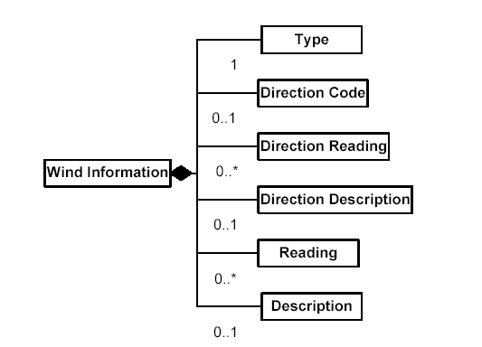

      - Child Elements
Name | Type
Definition | Type of wind information.
Type | Code. Type
Occurrence | 1

Name | DirectionCode
Definition | Code identifying the direction of wind.
Type | Code. Type
Occurrence | 0-1

Name | DirectionReading
Definition | Expression of direction of wind as a measurement.
Type | Reading. Type
Occurrence | 0-*

Name | DirectionDescription
Definition | Textual statement describing or related to the wind direction at the particular environment.
Type | Text. Type
Occurrence | 0-1 | Max. Length | 210

Name | Reading
Definition | Measurement of strength of wind.
Type | Reading. Type
Occurrence | 0-*

Name | Description
Definition | Textual statement describing or related to the wind at the particular environment.
Type | Text. Type
Occurrence | 0-1 | Max. Length | 210
Example
<WindInformation>
<Type>M</Type>
<DirectionCode>E</DirectionCode>
<DirectionReading>
<Measure unitCode="ZZ">90</Measure>
<UnitCode>DD</UnitCode>
</DirectionReading>
<Reading>
<Measure unitCode="ZZ">60</Measure>
<UnitCode>KMH</UnitCode>
</Reading>
<Description>Strong Wind.</Description>
</WindInformation>

    - Rainfall Information
Name | RainfallInformation. Type
Definition | Information related to rainfall at a particular environment.
Structure | 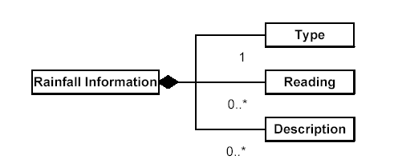

      - Child Elements
Name | Type
Definition | Type of rainfall information.
Type | Code. Type
Occurrence | 1

Name | Reading
Definition | Measurement of rainfall.
Type | Reading. Type
Occurrence | 0-*

Name | Description
Definition | Textual statement describing or related to the rainfall at the particular environment.
Type | Text. Type
Occurrence | 0-* | Max. Length | 210

Example
<RainfallInformation>
<Type>T</Type>
<Reading>
<Measure unitCode="ZZ">104.3</Measure>
<UnitCode>MMT</UnitCode>
</Reading>
<Description>AGAINST AN AVERAGE OF 82.3 MM</Description>
</RainfallInformation>

    - Sunshine Information
Name | SunshineInformation. Type
Definition | Information related to sunshine at a particular environment.
Structure | 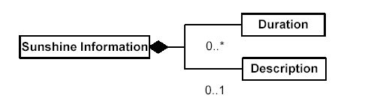

      - Child Elements
Name | Duration
Definition | Measurement of sunshine duration.
Type | Reading. Type
Occurrence | 0-*

Name | Description
Definition | Textual statement describing or related to the sunshine at the particular environment.
Type | Text. Type
Occurrence | 0-1 | Max. Length | 210

Example
<SunshineInformation>
<Duration>
<Measure unitCode="ZZ">140.7</Measure>
<UnitCode>HUR</UnitCode>
</Duration>
<Description>43.0 hours above the normal figure.</Description>
</SunshineInformation>

    - Ultraviolet Information
Name | UltravioletInformation. Type
Definition | Information related to ultraviolet at a particular environment.
Structure | 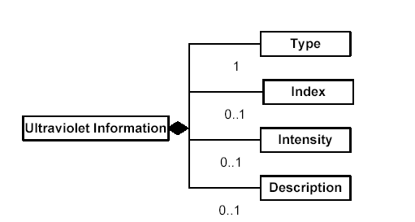

      - Child Elements
Name | Type
Definition | Type of ultraviolet information.
Type | Code. Type
Occurrence | 1

Name | Index
Definition | Index indicating the strength of ultraviolet.
Type | Numeric. Type
Occurrence | 0-1

Name | Intensity
Definition | Intensity of ultraviolet.
Type | Code. Type
Occurrence | 0-1

Name | Description
Definition | Textual statement describing or related to the ultraviolet at the particular environment.
Type | Text. Type
Occurrence | 0-1 | Max. Length | 210

Example
<UltravioletInformation>
<Type>M</Type>
<Index>3</Index>
<Intensity>M</Intensity>
</UltravioletInformation>

    - Radiation Information
Name | RadiationInformation. Type
Definition | Information related to radiation at a particular environment.
Structure | 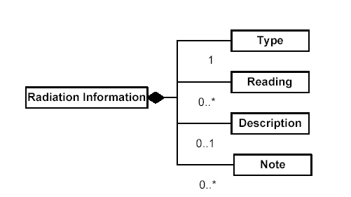

      - Child Elements
Name | Type
Definition | Type of radiation information.
Type | Code. Type
Occurrence | 1

Name | Reading
Definition | Measurement of radiation.
Type | Reading. Type
Occurrence | 0-*

Name | Description
Definition | Textual statement describing or related to the radiation at the particular environment.
Type | Text. Type
Occurrence | 0-1 | Max. Length | 700

Name | Note
Definition | Additional information on radiation.
Type | Text. Type
Occurrence | 0-* | Max. Length | 700

Example
<RadiationInformation>
<Type>M</Type>
<Description>AVERAGE AMBIENT GAMMA RADIATION DOSE RATE TAKEN OUTDOORS IN HONG KONG RANGED FROM 0.09 TO 0.14 MICROSIEVERT PER HOUR. THESE ARE WITHIN THE NORMAL RANGE OF FLUCTUATION OF THE BACKGROUND RADIATION LEVEL IN HONG KONG.</Description>
<Note>FROM READINGS TAKEN AT VARIOUS LOCATIONS IN HONG KONG DURING THE PERIOD 1987-1993, THE BACKGROUND AMBIENT GAMMA RADIATION LEVELS MAY VARY BETWEEN 0.06 AND 0.3 MICROSIEVERT PER HOUR.</Note>
</RadiationInformation>

    - Pressure Information
Name | PressureInformation. Type
Definition | Information related to pressure at a particular environment.
Structure | 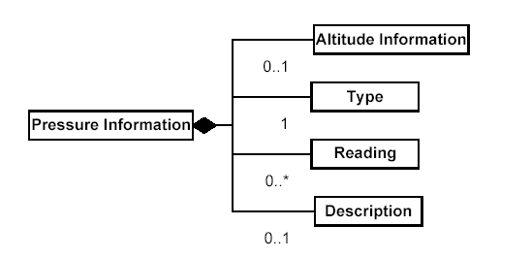

      - Child Elements
Name | AltitudeInformation
Definition | Information on altitude specifying the environment at which the pressure information is referring to.
Type | AltitudeInformation. Type
Occurrence | 0-1

Name | Type
Definition | Type of pressure information.
Type | Code. Type
Occurrence | 1

Name | Reading
Definition | Measurement of pressure.
Type | Reading. Type
Occurrence | 0-*

Name | Description
Definition | Textual statement describing or related to the pressure at the particular environment.
Type | Text. Type
Occurrence | 0-1 | Max. Length | 210

Example
<PressureInformation>
<AltitudeInformation>
<Altitude>
<Measure unitCode="ZZ">0</Measure>
<UnitCode>MTR</UnitCode>
</Altitude>
<ReferencePoint>S</ReferencePoint>
</AltitudeInformation>
<Type>I</Type>
<Reading>
<Measure unitCode="ZZ">1020.6</Measure>
<UnitCode>A97</UnitCode>
</Reading>
</PressureInformation>

    - Visibility Information
Name | VisibilityInformation. Type
Definition | Information related to visibility at a particular environment.
Structure | 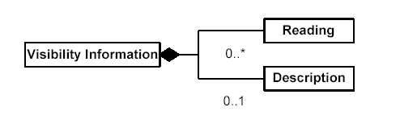

      - Child Elements
Name | Reading
Definition | Measurement of visibility.
Type | Reading. Type
Occurrence | 0-*

Name | Description
Definition | Textual statement describing or related to the visibility at the particular environment.
Type | Text. Type
Occurrence | 0-1 | Max. Length | 210

Example
<VisibilityInformation>
<Reading>
<Measure unitCode="ZZ">25</Measure>
<UnitCode>KTM</UnitCode>
</Reading>
</VisibilityInformation>

    - Sea Situation Information
Name | SeaSituationInformation. Type
Definition | Information related to sea situation at a particular environment.
Structure | 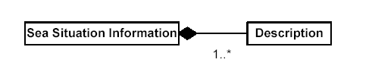

      - Child Elements
Name | Description
Definition | Textual statement describing or related to the sea situation at the particular environment.
Type | Text. Type
Occurrence | 1-* | Max. Length | 210

Example
<SeaSituationInformation>
<Description>MODERATE TO ROUGH SEAS</Description>
</SeaSituationInformation>

    - Tropical Cyclone Information
Name | TropicalCycloneInformation. Type
Definition | Information related to tropical cyclone at a particular environment.
Structure | 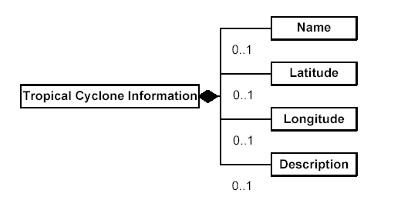

      - Child Elements
Name | Name
Definition | Name of tropical cyclone.
Type | Text. Type
Occurrence | 0-1 | Max. Length | 210

Name | Latitude
Definition | Latitude indicating the position of the tropical cyclone.
Type | Text. Type
Occurrence | 0-1
Pattern | 1-3 digits with optionally 0-2 fractional digits, followed by optionally “N” or “S”.

Name | Longitude
Definition | Longitude indicating the position of the tropical cyclone.
Type | Text. Type
Occurrence | 0-1
Pattern | 1-3 digits with optionally 0-2 fractional digits, followed by optionally “E” or “W”.

Name | Description
Definition | Textual statement describing or related to the tropical cyclone at the particular environment.
Type | Text. Type
Occurrence | 0-1 | Max. Length | 210

Example
<TropicalCycloneInformation>
<Name>TROPICAL STORM MELOR</Name>
<Latitude>23.7N</Latitude>
<Longitude>123.6E</Longitude>
</TropicalCycloneInformation>

    - Sea Wave Information
Name | SeaWaveInformation. Type
Definition | Information related to sea wave at a particular environment.
Structure | 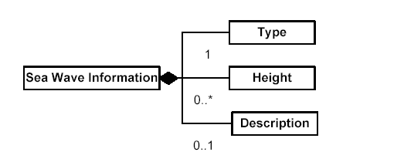

      - Child Elements
Name | Type
Definition | Type of sea wave information.
Type | Code. Type
Occurrence | 1

Name | Height
Definition | Measurement of height of sea wave.
Type | Reading. Type
Occurrence | 0-*

Name | Description
Definition | Textual statement describing or related to the sea wave at the particular environment.
Type | Text. Type
Occurrence | 0-1 | Max. Length | 210

Example
<SeaWaveInformation>
<Type>X</Type>
<Height>
<Measure unitCode="ZZ">2</Measure>
<UnitCode>MTR</UnitCode>
</Height>
</SeaWaveInformation>

    - Swell Information
Name | SwellInformation. Type
Definition | Information related to swell at a particular environment.
Structure | 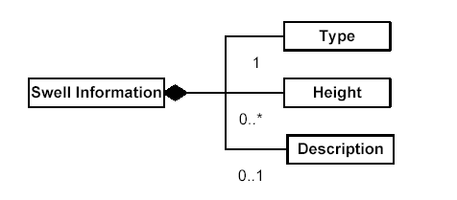

      - Child Elements
Name | Type
Definition | Type of swell information.
Type | Code. Type
Occurrence | 1

Name | Height
Definition | Measurement of height of swell.
Type | Reading. Type
Occurrence | 0-*

Name | Description
Definition | Textual statement describing or related to the swell at the particular environment.
Type | Text. Type
Occurrence | 0-1 | Max. Length | 210

Example
<SwellInformation>
<Type>X</Type>
<Height>
<Measure unitCode="ZZ">2</Measure>
<UnitCode>MTR</UnitCode>
</Height>
<Description>DUE TO THE NORTHEAST MONSOON.</Description>
</SwellInformation>

    - Solar Lunar Information
Name | SolarLunarInformation. Type
Definition | Information related to sun or moon activity at a particular environment.
Structure | 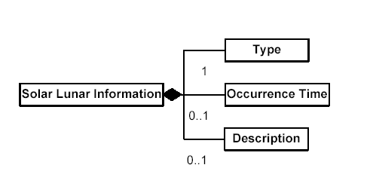

      - Child Elements
Name | Type
Definition | Type of solar/lunar activity.
Type | Code. Type
Occurrence | 1

Name | OccurrenceTime
Definition | Time at which the solar/lunar activity takes place.
Type | DateTime. Type
Occurrence | 0-1

Name | Description
Definition | Textual statement describing or related to the sun or moon activity at the particular environment.
Type | Text. Type
Occurrence | 0-1 | Max. Length | 210

Example
<SolarLunarInformation>
<Type>SR</Type>
<OccurrenceTime>2004-03-05T06:41:00+08:00</OccurrenceTime>
</SolarLunarInformation>

    - Tidal Information
Name | TidalInformation. Type
Definition | Information related to tide at a particular environment.
Structure | 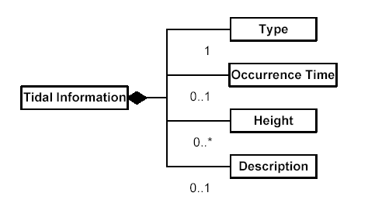

      - Child Elements
Name | Type
Definition | Type of tide information.
Type | Code. Type
Occurrence | 1

Name | OccurrenceTime
Definition | Time at which the tidal activity takes place.
Type | DateTime. Type
Occurrence | 0-1

Name | Height
Definition | Measurement of height of tide.
Type | Reading. Type
Occurrence | 0-*

Name | Description
Definition | Textual statement describing or related to the tide at the particular environment.
Type | Text. Type
Occurrence | 0-1 | Max. Length | 210

Example
<TidalInformation>
<Type>H</Type>
<OccurrenceTime>2004-03-05T20:17:00+08:00</OccurrenceTime>
<Height>
<Measure unitCode="ZZ">2.2</Measure>
<UnitCode>MTR</UnitCode>
</Height>
</TidalInformation>

    - Time Range
Name | TimeRange. Type
Definition | Range of time.
Structure | 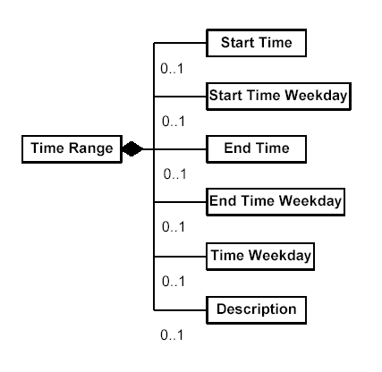

      - Child Elements
Name | StartTime
Definition | Starting time of the time range.
Type | DateTime. Type
Occurrence | 0-1

Name | StartTimeWeekday
Definition | Weekday on which the time range starts.
Type | Code. Type
Occurrence | 0-1

Name | EndTime
Definition | Ending time of the time range.
Type | DateTime. Type
Occurrence | 0-1

Name | EndTimeWeekday
Definition | Weekday on which the time range ends.
Type | Code. Type
Occurrence | 0-1

Name | TimeWeekday
Definition | Weekday on which the time includes.
Type | Code. Type
Occurrence | 0-1

Name | Description
Definition | Textual statement describing or related to the time range.
Type | Text. Type
Occurrence | 0-1 | Max. Length | 210

Example
<TimeRange>
<StartTime>2004-02-06T00:00:00+08:00</StartTime>
<StartTimeWeekday>5</StartTimeWeekday>
<EndTime>2004-02-07T00:00:00+08:00</EndTime>
<EndTimeWeekday>5</EndTimeWeekday>
</TimeRange >

    - Weather Icon
Name | WeatherIcon. Type
Definition | Icon representing the weather situation.
Structure | 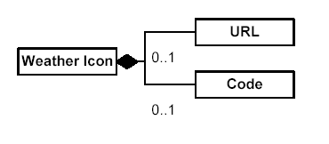

      - Child Elements
Name | URL
Definition | URL at which the weather icon can be obtained.
Type | URI. Type
Occurrence | 0-1

Name | Code
Definition | Code identifying the weather icon.
Type | Code. Type
Occurrence | 0-1

Example
<WeatherIcon>
<URL>http://www.weather.gov.hk/images/wxicon/pic77.png</URL>
<Code>MF</Code>
</WeatherIcon>

    - PSR
Name | PSR
Definition | Represent the probability of significant rainfall
Structure | 

      - Child Elements
Name | Value
Definition | Textual statement describing the probability of significant rain
Type | Text. Type
Occurrence | 1

Example
<PSR>
<Value>Low</Value>
</PSR>

  - Components in Bulletin
    - Bulletin Header
Name | BulletinHeader. Type
Definition | Header information of a bulletin, including name, type, provider, time of generation, copyright, disclaimer and other information regarding the bulletin.
Structure | 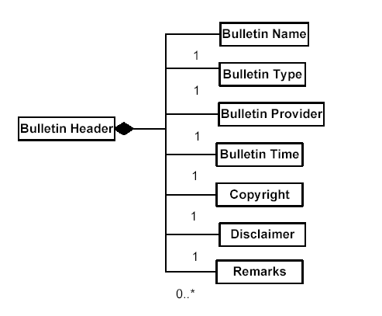

      - Child Elements
Name | BulletinName
Definition | Name of bulletin.
Type | Text. Type
Occurrence | 1 | Max. Length | 70

Name | BulletinType
Definition | Type of bulletin.
Type | Code. Type
Occurrence | 1

Name | BulletinProvider
Definition | Name of party providing the bulletin.
Type | Text. Type
Occurrence | 1 | Max. Length | 70

Name | BulletinTime
Definition | Time at which the bulletin is generated.
Type | DateTime. Type
Occurrence | 1

Name | Copyright
Definition | Declaration stating the copyright protecting the bulletin.
Type | Text. Type
Occurrence | 1 | Max. Length | 700

Name | Disclaimer
Definition | Disclaimer declared regarding the content of the bulletin.
Type | Text. Type
Occurrence | 1 | Max. Length | 700

Name | Remarks
Definition | Additional information related to the bulletin.
Type | Text. Type
Occurrence | 0-* | Max. Length | 700

Example
<BulletinHeader>
<BulletinName>Hong Kong Weather Report</BulletinName>
<BulletinType>R</BulletinType>
<BulletinProvider>Hong Kong Observatory</BulletinProvider>
<BulletinTime>2004-03-04T14:02:17+08:00</BulletinTime>
<Copyright>Copyright belongs to HKO.</Copyright>
<Disclaimer>HKO makes no warranty to the accuracy of the information.</Disclaimer>
<Remarks>Please contact HKO for enquiry.</Remarks>
</BulletinHeader>

    - Location
Name | Location. Type
Definition | Information of a site at which an object is situated or a place is located.
Structure | 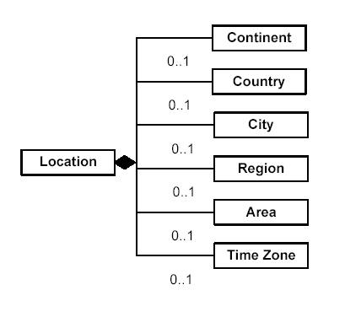

      - Child Elements
Name | Continent
Definition | Continent at which an object is situated or a place is located.
Type | Text. Type
Occurrence | 0-1 | Max. Length | 210

Name | Country
Definition | Country at which an object is situated or a place is located.
Type | Text. Type
Occurrence | 0-1 | Max. Length | 210

Name | City
Definition | City at which an object is situated or a place is located.
Type | Text. Type
Occurrence | 0-1 | Max. Length | 210

Name | Region
Definition | Region at which an object is situated or a place is located.
Type | Text. Type
Occurrence | 0-1 | Max. Length | 210

Name | Area
Definition | Area at which an object is situated or a place is located.
Type | Text. Type
Occurrence | 0-1 | Max. Length | 210

Name | TimeZone
Definition | Time zone of the site at which an object is situated or a place is located.
Type | Text. Type
Occurrence | 0-1

Example
<Location>
<Continent>Asia</Continent>
<Country>China</Country>
<City>Hong Kong</City>
<Region>Kowloon</Region>
<Area>Jordan</Area>
<TimeZone>HKT</TimeZone>
</Location>
    - Special Announcement
Name | SpecialAnnouncement. Type
Definition | Special Announcement issued by the Hong Kong Observatory
Structure | 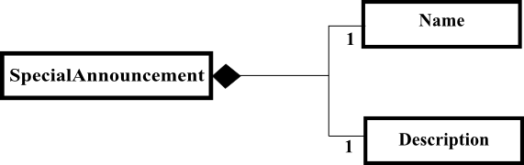

      - Child Elements

Name | Name
Definition | Type of the special announcement.
Type | Text. Type
Occurrence | 1 | Max. Length | 700

Name | Description
Definition | Information of the special announcement.
Type | Text. Type
Occurrence | 1 | Max. Length | 700

Example
<SpecialAnnouncement>
<Name>Gust Forecast</Name>
<Description>Gusts reaching 70 kilometres per hour or above may affect northern part of the New Territories.</Description>
</SpecialAnnouncement>
    - Special Weather Tip
Name | SpecialWeatherTip. Type
Definition | Special Weather Tip issued by the Hong Kong Observatory
Structure | 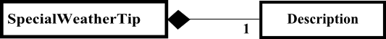

      - Child Elements

Name | Description
Definition | Information of the special weather tip.
Type | Text. Type
Occurrence | 1 | Max. Length | 700

Example
<SpecialWeatherTip>
<Description>Widespread heavy rain may affect Hong Kong shortly. Members of the public should be on the alert.</Description>
</SpecialWeatherTip>

    - Warning Info
Name | WarningInfo. Type
Definition | Warning in force
Structure | 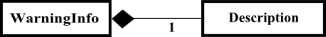

      - Child Elements

Name | Description
Definition | Content of the warning in force.
Type | Text. Type
Occurrence | 1 | Max. Length | 700

Example
<WarningInfo>
<Description>THE VERY HOT WEATHER WARNING IS NOW IN FORCE. HOT WEATHER MIGHT CAUSE ADVERSE HEALTH EFFECTS. MEMBERS OF THE PUBLIC SHOULD TAKE CARE TO AVOID HEATSTROKE.</Description>
</WarningInfo>
    - Tropical Cyclone Info
Name | TropicalCycloneInfo. Type
Definition | Tropical Cyclone information
Structure | 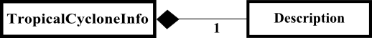

      - Child Elements

Name | Description
Definition | Tropical cyclone information
Type | Text. Type
Occurrence | 1 | Max. Length | 700

    - Lightning Info
Name | LightningInfo. Type
Definition | Lightning information
Structure | 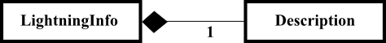

      - Child Elements

Name | Description
Definition | Lightning information
Type | Text. Type
Occurrence | 1 | Max. Length | 700

Weather Forecast
Name | WeathreForecast. Type
Definition | Information on weather predicted.
Structure | 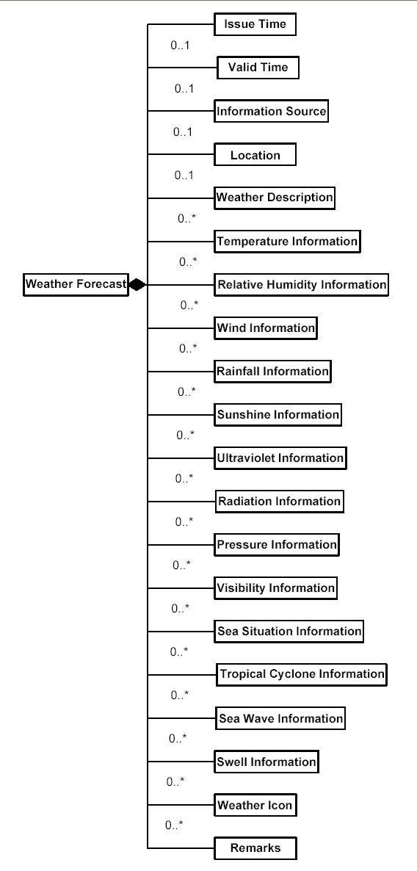

      - Child Elements
Name | IssueTime
Definition | Time at which the prediction is issued.
Type | DateTime. Type
Occurrence | 0-1

Name | ValidTime
Definition | Time range during which the prediction is valid.
Type | TimeRange. Type
Occurrence | 0-1

Name | InformationSource
Definition | Information of party which is the source of the prediction.
Type | InformationSource. Type
Occurrence | 0-1

Name | Location
Definition | Information of the place for which the prediction is issued.
Type | Location. Type
Occurrence | 0-1

Name | WeatherDescription
Definition | Statement representing the weather situation predicted.
Type | Text. Type
Occurrence | 0-* | Max. Length | 700

Name | TemperatureInformation
Definition | Predicted information on temperature.
Type | TemperatureInformation. Type
Occurrence | 0-*

Name | RelativeHumidityInformation
Definition | Predicted information on relative humidity.
Type | RelativeHumidityInformation. Type
Occurrence | 0-*

Name | WindInformation
Definition | Predicted information on strength of wind.
Type | WindInformation. Type
Occurrence | 0-*

Name | RainfallInformation
Definition | Predicted information on amount of rainfall.
Type | RainfallInformation. Type
Occurrence | 0-*

Name | SunshineInformation
Definition | Predicted information on amount of sunshine.
Type | SunshineInformation. Type
Occurrence | 0-*

Name | UltravioletInformation
Definition | Predicted information on strength of ultraviolet.
Type | UltravioletInformation. Type
Occurrence | 0-*

Name | RadiationInformation
Definition | Predicted information on amount of radiation.
Type | RadiationInformation. Type
Occurrence | 0-*

Name | PressureInformation
Definition | Predicated information on amount of pressure.
Type | PressureInformation. Type
Occurrence | 0-*

Name | VisibilityInformation
Definition | Predicted information on visibility.
Type | VisibilityInformation. Type
Occurrence | 0-*

Name | SeaSituationInformation
Definition | Predicted information on sea situation.
Type | SeaSituationInformation. Type
Occurrence | 0-*

Name | TropicalCycloneInformation
Definition | Predicted information on tropical cyclone.
Type | TropicalCycloneInformation. Type
Occurrence | 0-*

Name | SeaWaveInformation
Definition | Predicted information on sea wave.
Type | SeaWaveInformation. Type
Occurrence | 0-*

Name | SwellInformation
Definition | Predicted information on swell.
Type | SwellInformation. Type
Occurrence | 0-*

Name | WeatherIcon
Definition | Icon representing the weather situation predicted.
Type | WeatherIcon. Type
Occurrence | 0-*

Name | Remarks
Definition | Additional information related to the predicted weather.
Type | Text. Type
Occurrence | 0-* | Max. Length | 210

Example
<WeatherForecast>
<IssueTime>2004-02-06T15:00:00+08:00</IssueTime>
<ValidTime>
<StartTime>2004-02-06T18:00:00+08:00</StartTime>
<EndTime>2004-02-07T18:00:00+08:00</EndTime>
</ValidTime>
<InformationSource>
<CenterName>CMA</CenterName>
</InformationSource>
<Location>
<City>GUANGZHOU</City>
</Location>
<WeatherDescription>Mainly Fine.</WeatherDescription>
<TemperatureInformation>……</TemperatureInformation>
<RelativeHumidityInformation>……</RelativeHumidityInformation>
<WindInformation>……</WindInformation>
<RainfallInformation>……</RainfallInformation >
<SunshineInformation>……</SunshineInformation >
<UltravioletInformation>……</UltravioletInformation >
<RadiationInformation>…… </RadiationInformation >
<PressureInformation>……</PressureInformation >
<VisibilityInformation>……</VisibilityInformation >
<SeaSituationInformation……</SeaSituationInformation >
<TropicalCycloneInformation>……</TropicalCycloneInformation >
<SeaWaveInformation>……</SeaWaveInformation >
<SwellInformation>……</SwellInformation >
<WeatherIcon>
<URL>http://www.weather.gov.hk/images/wxicon/pic77.png</URL>
<Code>MF</Code>
</WeatherIcon>
<Remarks>Next Update will be on 23:00.</Remarks>
</WeatherForecast>

    - Weather Report
Name | WeatherReport. Type
Definition | Information on weather recorded.
Structure | 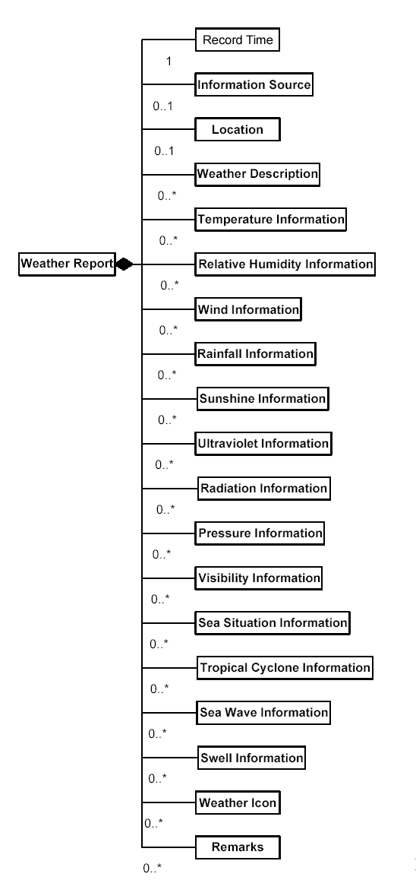
      - Child Elements
Name | RecordTime
Definition | Time range during which the weather is recorded.
Type | TimeRange. Type
Occurrence | 1

Name | InformationSource
Definition | Information of party which is the source of the report.
Type | InformationSource. Type
Occurrence | 0-1

Name | Location
Definition | Information of the place at which the weather is recorded.
Type | Location. Type
Occurrence | 0-1

Name | WeatherDescription
Definition | Statement representing the weather situation recorded.
Type | Text. Type
Occurrence | 0-* | Max. Length | 700

Name | TemperatureInformation
Definition | Recorded information on temperature.
Type | TemperatureInformation. Type
Occurrence | 0-*

Name | RelativeHumidityInformation
Definition | Recorded information on relative humidity.
Type | RelativeHumidityInformation. Type
Occurrence | 0-*

Name | WindInformation
Definition | Recorded information on strength of wind.
Type | WindInformation. Type
Occurrence | 0-*

Name | RainfallInformation
Definition | Recorded information on amount of rainfall.
Type | RainfallInformation. Type
Occurrence | 0-*

Name | SunshineInformation
Definition | Recorded information on amount of sunshine.
Type | SunshineInformation. Type
Occurrence | 0-*

Name | UltravioletInformation
Definition | Recorded information on strength of ultraviolet.
Type | UltravioletInformation. Type
Occurrence | 0-*

Name | RadiationInformation
Definition | Recorded information on amount of radiation.
Type | RadiationInformation. Type
Occurrence | 0-*

Name | PressureInformation
Definition | Recorded information on amount of pressure.
Type | PressureInformation. Type
Occurrence | 0-*

Name | VisibilityInformation
Definition | Recorded information on visibility.
Type | VisibilityInformation. Type
Occurrence | 0-*

Name | SeaSituationInformation
Definition | Recorded information on sea situation.
Type | SeaSituationInformation. Type
Occurrence | 0-*

Name | TropicalCycloneInformation
Definition | Recorded information on tropical cyclone.
Type | TropicalCycloneInformation. Type
Occurrence | 0-*

Name | SeaWaveInformation
Definition | Recorded information on sea wave.
Type | SeaWaveInformation. Type
Occurrence | 0-*

Name | SwellInformation
Definition | Recorded information on swell.
Type | SwellInformation. Type
Occurrence | 0-*

Name | WeatherIcon
Definition | Icon representing the weather situation recorded.
Type | WeatherIcon. Type
Occurrence | 0-*

Name | Remarks
Definition | Additional information related to the recorded weather.
Type | Text. Type
Occurrence | 0-* | Max. Length | 210

      - Example
<WeatherReport>
<RecordTime>
<StartTime>2004-02-05T18:00:00+08:00</StartTime>
<EndTime>2004-02-05T18:00:00+08:00</EndTime>
</RecordTime >
<InformationSource>
<CenterName>CMA</CenterName>
</InformationSource>
<Location>
<City>GUANGZHOU</City>
</Location>
<WeatherDescription>Mainly Fine.</WeatherDescription>
<TemperatureInformation>……</TemperatureInformation>
<RelativeHumidityInformation>……</RelativeHumidityInformation>
<WindInformation>……</WindInformation>
<RainfallInformation>……</RainfallInformation >
<SunshineInformation>……</SunshineInformation >
<UltravioletInformation>……</UltravioletInformation >
<RadiationInformation>…… </RadiationInformation >
<PressureInformation>……</PressureInformation >
<VisibilityInformation>……</VisibilityInformation >
<SeaSituationInformation……</SeaSituationInformation >
<TropicalCycloneInformation>……</TropicalCycloneInformation >
<SeaWaveInformation>……</SeaWaveInformation >
<SwellInformation>……</SwellInformation >
<WeatherIcon>
<URL>http://www.weather.gov.hk/images/wxicon/pic77.png</URL>
<Code>MF</Code>
</WeatherIcon>
<Remarks>Next Update will be on 23:00.</Remarks>
</WeatherReport >

    - Weather Announcement
Name | WeatherAnnouncement. Type
Definition | Announcement made due to special weather situation.
Structure | 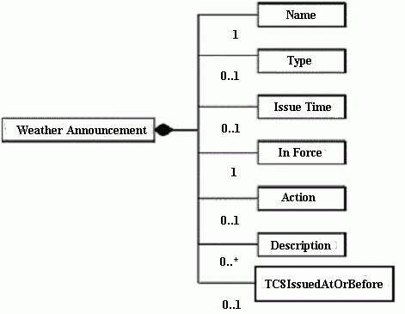

      - Child Elements
Name | Name
Definition | Name of the weather announcement.
Type | Text. Type
Occurrence | 1 | Max. Length | 210

Name | Type
Definition | Type of the weather announcement. If there is more than one kind of weather announcement under the same name, this is used for identification. For example, if there are two types of rainstorm announcement, this field is used to differentiate the two.
Type | Text. Type
Occurrence | 0-1
Name | IssueTime
Definition | Date and time at which the announcement is issued.
Type | DateTime. Type
Occurrence | 0-1

Name | InForce
Definition | Indicator identifying whether the announcement is in force (0/false = not in force, 1/true = in force).
Type | Indicator. Type
Occurrence | 1

Name | Action
Definition | Action taken regarding the weather announcement.
Type | Code. Type
Occurrence | 0-1

Name | TC8IssuedAtOrBefore
Definition | Date and time at or before which Tropical Cyclone Warning Signal Number 8 issued.
Type | DateTime. Type
Occurrence | 0-1

Name | Description
Definition | Statement describing the details of the weather announcement.
Type | Text. Type
Occurrence | 0-* | Max. Length | 2100

      - Example
<WeatherAnnouncement>
<Name>Special Announcement On Flooding In Northern NT</Name>
<IssueTime>2003-06-11T00:01:00+08:00</IssueTime>
<InForce>1</InForce>
<Action>I</Action>
<Description>SPECIAL ANNOUNCEMENT ON FLOODING IN THE NORTHERN NEW TERRITORIES ISSUED BY THE HONG KONG OBSERVATORY AT 0:01 A.M. ON 11 JUN : RESIDENTS IN THE NORTHERN NEW TERRITORIES, WHO ARE LIKELY TO BE AFFECTED, ARE ADVISED TO TAKE NECESSARY PRECAUTIONS TO AVOID POSSIBLE FLOOD DAMAGE. </Description>
</WeatherAnnouncement>

    - Weather Warning
Name | WeatherWarning. Type
Definition | Warning issued due to special weather situation.
Structure | 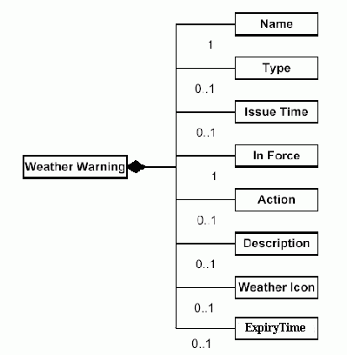

      - Child Elements
Name | Name
Definition | Name of the weather warning.
Type | Text. Type
Occurrence | 1 | Max. Length | 210

Name | Type
Definition | Type of the weather warning. If there is more than one kind of weather warning under the same name, this is used for identification. For example, if there are two types of tropical cyclone warning, this field is used to differentiate the two.
Type | Text. Type
Occurrence | 0-1

Name | IssueTime
Definition | Date and time at which the warning is issued.
Type | DateTime. Type
Occurrence | 0-1

Name | InForce
Definition | Indicator identifying whether the warning is in force (0/false = not in force, 1/true = in force).
Type | Indicator. Type
Occurrence | 1

Name | Action
Definition | Action taken regarding the weather warning.
Type | Code. Type
Occurrence | 0-1

Name | ExpiryTime
Definition | Date and time at which the warning is expired.
Type | DateTime. Type
Occurrence | 0-1

Name | Description
Definition | Statement describing the details of the weather warning.
Type | Text. Type
Occurrence | 0-1 | Max. Length | 2100

Name | WeatherIcon
Definition | Icon representing the weather warning.
Type | WeatherIcon. Type
Occurrence | 0-1

      - Example
<WeatherWarning>
<Name>Tropical Cyclone Warning Signal</Name>
<Type>Standby Signal No. 1</Type>
<IssueTime>2002-09-10T14:40:00+08:00</IssueTime>
<InForce>1</InForce>
<Action>I</Action>
<Description>THE STANDBY SIGNAL, NO. 1, WAS ISSUED AT 2:40 P.M.</Description>
</WeatherWarning>

    - Astronomical Information
Name | AstronomicalInformation. Type
Definition | Information related to astronomy, including data on tide, sun and moon.
Structure | 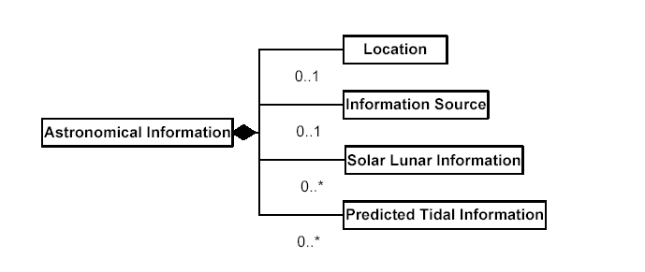

      - Child Elements
Name | Location
Definition | Information of the place for which the astronomical information is prepared.
Type | Location. Type
Occurrence | 0-1

Name | InformationSource
Definition | Information of party which is the source of the astronomical information.
Type | InformationSource. Type
Occurrence | 0-1

Name | SolarLunarInformation
Definition | Information regarding sun and moon.
Type | SolarLunarInformation. Type
Occurrence | 0-*

Name | PredictedTidalInformation
Definition | Information regarding predicted tide.
Type | TidalInformation. Type
Occurrence | 0-*

      - Example
<AstronomicalInformation>
<Location>
<City>Hong Kong</City>
</Location>
<InformationSource>
<CenterName>Hong Kong Observatory</CenterName>
</InformationSource>
<SolarLunarInformation>……</SolarLunarInformation>
<PredictedTidalInformation>……</PredictedTidalInformation>
</AstronomicalInformation>

    - Information Source
Name | InformationSource. Type
Definition | Identification of a source of information by name and/or location. The transmission method may also be included.
Structure | 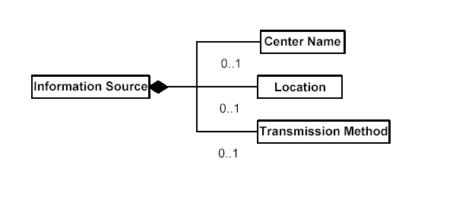

      - Child Elements
Name | CenterName
Definition | Name of party providing the information.
Type | Text. Type
Occurrence | 0-1 | Max. Length | 210

Name | Location
Definition | Location of party providing the information.
Type | Location. Type
Occurrence | 0-1

Name | TransmissionMethod
Definition | Method employed by the party as a mean to transfer the data.
Type | Code. Type
Occurrence | 0-1

      - Example
<InformationSource>
<CenterName>Hong Kong Observatory</CenterName>
<Location>
<Country>China</Country>
<City>Hong Kong</City>
</Location>
<TransmissionMethod>FTP</TransmissionMethod>
</InformationSource>

    - Tsunami Information
Name | TsunamiInformation. Type
Definition | Information related to tsunami.
Structure | 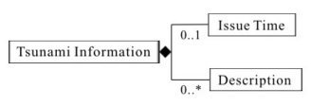

      - Child Elements
Name | IssueTime
Definition | Date and time at which the information is issued.
Type | DateTime. Type
Occurrence | 0-1

Name | Description
Definition | Statement describing the details of the tsunami information.
Type | Text. Type
Occurrence | 0-* | Max. Length | 2100

      - Example
<TsunamiInformation>
<IssueTime>2005-12-30T03:15:00+08:00</IssueTime>
<Description>…… </Description>
</TsunamiInformation>

    - Tsunami Warning
Name | TsunamiWarning. Type
Definition | Warning issued due to tsunami.
Structure | 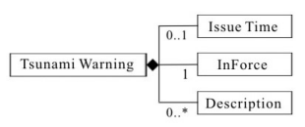

      - Child Elements
Name | IssueTime
Definition | Date and time at which the warning is issued.
Type | DateTime. Type
Occurrence | 0-1

Name | InForce
Definition | Indicator identifying whether the warning is in force (0/false = not in force, 1/true = in force).
Type | Indicator. Type
Occurrence | 1

Name | Description
Definition | Statement describing the details of the tsunami warning.
Type | Text. Type
Occurrence | 0-* | Max. Length | 2100

      - Example
<TsunamiWarning>
<IssueTime>2005-12-30T03:15:00+08:00</IssueTime>
<InForce>1</InForce>
<Description>…… </Description>
</TsunamiWarning>

- Bulletin
    - Weather Bulletin
Root | WeatherBulletin
Type | WeatherBulletin. Type
Definition | Bulletin including different types of weather information. It may include weather forecast, weather report, weather announcement and weather warning.
Structure | 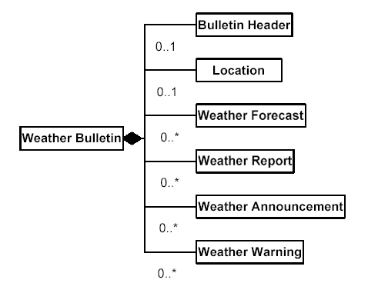

      - Child Elements
Name | BulletinHeader
Definition | Bulletin header of a Weather Bulletin.
Type | BulletinHeader. Type
Occurrence | 0-1

Name | Location
Definition | Identification of a place for which the Weather Bulletin is issued.
Type | Location. Type
Occurrence | 0-1

Name | WeatherForecast
Definition | Information on predicted weather included in a Weather Bulletin.
Type | WeatherForecast. Type
Occurrence | 0-*

Name | WeatherReport
Definition | Information on recorded weather included in a Weather Bulletin.
Type | WeatherReport. Type
Occurrence | 0-*

Name | WeatherAnnouncement
Definition | Information on weather announcement included in a Weather Bulletin.
Type | WeatherAnnouncement. Type
Occurrence | 0-*

Name | WeatherWarning
Definition | Information on weather warning included in a Weather Bulletin.
Type | WeatherWarning. Type
Occurrence | 0-*

      - Example
<?xml version="1.0" encoding="UTF-8"?>
<WeatherBulletin xmlns:xsi="http://www.w3.org/2001/XMLSchema-instance" xsi:noNamespaceSchemaLocation="https://xml3.weather.gov.hk/V3/schemas/WXNML_iso-8859.xsd">
<BulletinHeader>
<BulletinName>South China Coastal Waters</BulletinName>
<BulletinType>R</BulletinType>
<BulletinProvider>Hong Kong Observatory</BulletinProvider>
<BulletinTime>2004-02-07T12:30:15+08:00</BulletinTime>
<Copyright>……</Copyright>
<Disclaimer>……</Disclaimer>
<Remarks>……</Remarks>
</BulletinHeader>
<Location>
<City>Hong Kong</City>
</Location>
<WeatherForecast>
<TemperatureInformation>
<Medium>A</Medium>
<Type>N</Type>
<Reading>
<Measure unitCode="ZZ">17.9</Measure>
<UnitCode>CEL</UnitCode>
</Reading>
</TemperatureInformation>
<TemperatureInformation>
<Medium>A</Medium>
<Type>X</Type>
<Reading>
<Measure unitCode="ZZ">23.1</Measure>
<UnitCode>CEL</UnitCode>
</Reading>
</TemperatureInformation>
</WeatherForecast>
<WeatherReport>
<RecordTime>
<Description>Yesterday</Description>
</RecordTime>
<TemperatureInformation>
<Medium>A</Medium>
<Type>N</Type>
<Reading>
<Measure unitCode="ZZ">17.9</Measure>
<UnitCode>CEL</UnitCode>
</Reading>
</TemperatureInformation>
<TemperatureInformation>
<Medium>A</Medium>
<Type>X</Type>
<Reading>
<Measure unitCode="ZZ">23.1</Measure>
<UnitCode>CEL</UnitCode>
</Reading>
</TemperatureInformation>
</WeatherReport>
<WeatherAnnouncement>
<Name>Rainstorm Warning Announcement</Name>
<Type>Amber</Type>
<IssueTime>2004-02-07T10:45:00+08:00</IssueTime>
<InForce>1</InForce>
<Description>AMBER RAINSTORM WARNING SIGNAL SPECIAL ANNOUNCEMENT ISSUED AT 10:45 A.M. THE RAINSTORM WARNING SIGNAL IS NOW AMBER. THIS MEANS THAT HEAVY RAIN HAS FALLEN OR IS EXPECTED TO FALL GENERALLY OVER HONG KONG, EXCEEDING 30 MILLIMETRES IN AN HOUR. THERE WILL BE FLOODING IN SOME LOW-LYING AND POORLY DRAINED AREAS. PEOPLE WHO ARE LIKELY TO BE AFFECTED SHOULD TAKE NECESSARY PRECAUTIONS TO REDUCE THEIR EXPOSURE TO RISK POSED BY THE HEAVY RAIN AND FLOODING.</Description>
</WeatherAnnouncement>
<WeatherWarning>
<Name>Thunderstorm Warning</Name>
<IssueTime>2004-02-07T11:05:00+08:00</IssueTime>
<InForce>1</InForce>
<Action>I</Action>
</WeatherWarning>
</WeatherBulletin>

    - Weather Forecast
      - Several Days Weather Forecast
Root | SeveralDaysWeatherForecast
Name | SeveralDaysWeatherForecast. Type
Definition | Information including prediction of weather for the following day(s) and weather report.
Structure | 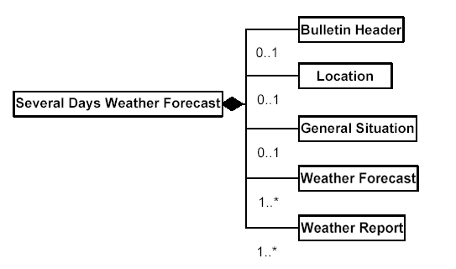

        - Child Elements
Name | BulletinHeader
Definition | Bulletin header of a Several Days Weather Forecast bulletin.
Type | BulletinHeader. Type
Occurrence | 0-1

Name | Location
Definition | Identification of a place for which the Several Days Weather Forecast bulletin is issued.
Type | Location. Type
Occurrence | 0-1

Name | GeneralSituation
Definition | Statement describing the general weather situation.
Type | Text. Type
Occurrence | 0-1 | Max. Length | 700

Name | WeatherForecast
Definition | Information on the weather predicted for the coming day(s).
Type | WeatherForecast. Type
Occurrence | 1-*

Name | WeatherReport
Definition | Information on weather recorded included in a Several Days Weather Forecast bulletin.
Type | WeatherReport. Type
Occurrence | 1-*

        - Example

<?xml version="1.0" encoding="UTF-8"?>
<SeveralDaysWeatherForecast xmlns:xsi="http://www.w3.org/2001/XMLSchema-instance" xsi:noNamespaceSchemaLocation="https://xml3.weather.gov.hk/V3/schemas/WXNML_iso-8859.xsd">
<BulletinHeader>
<BulletinName>9-day Weather Forecast</BulletinName>
<BulletinType>F</BulletinType>
<BulletinProvider>Hong Kong Observatory</BulletinProvider>
<BulletinTime>2014-04-01T11:30:00+08:00</BulletinTime>
<Copyright>The content available in this file, including but not limited to all text, graphics, drawings, diagrams, photographs and compilation of data or other materials are protected by copyright. The Government of the Hong Kong Special Administrative Region is the owner of all copyright works contained in this website. Any reproduction, adaptation, distribution, dissemination or making available of such copyright works to the public is strictly prohibited unless prior written authorization is obtained from the Hong Kong Observatory.</Copyright>
<Disclaimer>The Government of the Hong Kong Special Administrative Region (including its servants and agents) makes no warranty, statement or representation, express or implied, with respect to the accuracy, availability, completeness or usefulness of the information, contained herein, and in so far as permitted by law, shall not have any legal liability or responsibility (including liability for negligence) for any loss, damage, or injury (including death) which may result, whether directly or indirectly, from the supply or use of such information.</Disclaimer>
<Remarks>You are welcome to write to the Hong Kong Observatory for authorization to make available information on this file to the public. For enquires, please contact the Hong Kong Observatory by e-mail (mailbox@hko.gov.hk) or fax (2311 9448).</Remarks>
</BulletinHeader>
<GeneralSituation>A trough of low pressure will linger around the south China coastal areas in the next couple of days, bringing showers and squally thunderstorms to the region. The northeast monsoon will affect the south China coastal areas in the latter part of this week.</GeneralSituation>
<WeatherForecast>
<ValidTime>
<StartTime>2014-04-02T00:00:00+08:00</StartTime>
<StartTimeWeekday>3</StartTimeWeekday>
<EndTime>2014-04-03T00:00:00+08:00</EndTime>
<EndTimeWeekday>3</EndTimeWeekday>
</ValidTime>
<WeatherDescription>Cloudy with showers and a few squally thunderstorms.</WeatherDescription>
<TemperatureInformation>
<Medium>A</Medium>
<Type>N</Type>
<Reading>
<Measure unitCode="ZZ">20</Measure>
<UnitCode>CEL</UnitCode>
</Reading>
</TemperatureInformation>
<TemperatureInformation>
<Medium>A</Medium>
<Type>X</Type>
<Reading>
<Measure unitCode="ZZ">22</Measure>
<UnitCode>CEL</UnitCode>
</Reading>
</TemperatureInformation>
<RelativeHumidityInformation>
<Type>N</Type>
<Reading>
<Measure unitCode="ZZ">80</Measure>
<UnitCode>P1</UnitCode>
</Reading>
</RelativeHumidityInformation>
<RelativeHumidityInformation>
<Type>X</Type>
<Reading>
<Measure unitCode="ZZ">95</Measure>
<UnitCode>P1</UnitCode>
</Reading>
</RelativeHumidityInformation>
<WindInformation>
<Type>M</Type>
<Description>East force 3 to 4.</Description>
</WindInformation>
<WeatherIcon>
<URL>http://www.weather.gov.hk/images/wxicon/pic63.png</URL>
<Code>RN</Code>
</WeatherIcon>
</WeatherForecast>
<WeatherForecast>
<ValidTime>
<StartTime>2014-04-03T00:00:00+08:00</StartTime>
<StartTimeWeekday>4</StartTimeWeekday>
<EndTime>2014-04-04T00:00:00+08:00</EndTime>
<EndTimeWeekday>4</EndTimeWeekday>
</ValidTime>
<WeatherDescription>Cloudy with showers and a few squally thunderstorms, showers will be heavy at times.</WeatherDescription>
<TemperatureInformation>
<Medium>A</Medium>
<Type>N</Type>
<Reading>
<Measure unitCode="ZZ">19</Measure>
<UnitCode>CEL</UnitCode>
</Reading>
</TemperatureInformation>
<TemperatureInformation>
<Medium>A</Medium>
<Type>X</Type>
<Reading>
<Measure unitCode="ZZ">22</Measure>
<UnitCode>CEL</UnitCode>
</Reading>
</TemperatureInformation>
<RelativeHumidityInformation>
<Type>N</Type>
<Reading>
<Measure unitCode="ZZ">80</Measure>
<UnitCode>P1</UnitCode>
</Reading>
</RelativeHumidityInformation>
<RelativeHumidityInformation>
<Type>X</Type>
<Reading>
<Measure unitCode="ZZ">95</Measure>
<UnitCode>P1</UnitCode>
</Reading>
</RelativeHumidityInformation>
<WindInformation>
<Type>M</Type>
<Description>East to southeast force 3 to 4, becoming northeast force 4 later.</Description>
</WindInformation>
<WeatherIcon>
<URL>http://www.weather.gov.hk/images/wxicon/pic64.png</URL>
<Code>HR</Code>
</WeatherIcon>
</WeatherForecast>
<WeatherForecast>
<ValidTime>
<StartTime>2014-04-04T00:00:00+08:00</StartTime>
<StartTimeWeekday>5</StartTimeWeekday>
<EndTime>2014-04-05T00:00:00+08:00</EndTime>
<EndTimeWeekday>5</EndTimeWeekday>
</ValidTime>
<WeatherDescription>Mainly cloudy with a few showers.</WeatherDescription>
<TemperatureInformation>
<Medium>A</Medium>
<Type>N</Type>
<Reading>
<Measure unitCode="ZZ">18</Measure>
<UnitCode>CEL</UnitCode>
</Reading>
</TemperatureInformation>
<TemperatureInformation>
<Medium>A</Medium>
<Type>X</Type>
<Reading>
<Measure unitCode="ZZ">22</Measure>
<UnitCode>CEL</UnitCode>
</Reading>
</TemperatureInformation>
<RelativeHumidityInformation>
<Type>N</Type>
<Reading>
<Measure unitCode="ZZ">70</Measure>
<UnitCode>P1</UnitCode>
</Reading>
</RelativeHumidityInformation>
<RelativeHumidityInformation>
<Type>X</Type>
<Reading>
<Measure unitCode="ZZ">90</Measure>
<UnitCode>P1</UnitCode>
</Reading>
</RelativeHumidityInformation>
<WindInformation>
<Type>M</Type>
<Description>East to northeast force 4.</Description>
</WindInformation>
<WeatherIcon>
<URL>http://www.weather.gov.hk/images/wxicon/pic62.png</URL>
<Code>LR</Code>
</WeatherIcon>
</WeatherForecast>
<WeatherForecast>
<ValidTime>
<StartTime>2014-04-05T00:00:00+08:00</StartTime>
<StartTimeWeekday>6</StartTimeWeekday>
<EndTime>2014-04-06T00:00:00+08:00</EndTime>
<EndTimeWeekday>6</EndTimeWeekday>
</ValidTime>
<WeatherDescription>Sunny intervals.</WeatherDescription>
<TemperatureInformation>
<Medium>A</Medium>
<Type>N</Type>
<Reading>
<Measure unitCode="ZZ">18</Measure>
<UnitCode>CEL</UnitCode>
</Reading>
</TemperatureInformation>
<TemperatureInformation>
<Medium>A</Medium>
<Type>X</Type>
<Reading>
<Measure unitCode="ZZ">22</Measure>
<UnitCode>CEL</UnitCode>
</Reading>
</TemperatureInformation>
<RelativeHumidityInformation>
<Type>N</Type>
<Reading>
<Measure unitCode="ZZ">70</Measure>
<UnitCode>P1</UnitCode>
</Reading>
</RelativeHumidityInformation>
<RelativeHumidityInformation>
<Type>X</Type>
<Reading>
<Measure unitCode="ZZ">90</Measure>
<UnitCode>P1</UnitCode>
</Reading>
</RelativeHumidityInformation>
<WindInformation>
<Type>M</Type>
<Description>East to northeast force 4 to 5, occasionally force 6 offshore.</Description>
</WindInformation>
<WeatherIcon>
<URL>http://www.weather.gov.hk/images/wxicon/pic52.png</URL>
<Code>SI</Code>
</WeatherIcon>
</WeatherForecast>
<WeatherForecast>
<ValidTime>
<StartTime>2014-04-06T00:00:00+08:00</StartTime>
<StartTimeWeekday>0</StartTimeWeekday>
<EndTime>2014-04-07T00:00:00+08:00</EndTime>
<EndTimeWeekday>0</EndTimeWeekday>
</ValidTime>
<WeatherDescription>Mainly cloudy.</WeatherDescription>
<TemperatureInformation>
<Medium>A</Medium>
<Type>N</Type>
<Reading>
<Measure unitCode="ZZ">19</Measure>
<UnitCode>CEL</UnitCode>
</Reading>
</TemperatureInformation>
<TemperatureInformation>
<Medium>A</Medium>
<Type>X</Type>
<Reading>
<Measure unitCode="ZZ">22</Measure>
<UnitCode>CEL</UnitCode>
</Reading>
</TemperatureInformation>
<RelativeHumidityInformation>
<Type>N</Type>
<Reading>
<Measure unitCode="ZZ">70</Measure>
<UnitCode>P1</UnitCode>
</Reading>
</RelativeHumidityInformation>
<RelativeHumidityInformation>
<Type>X</Type>
<Reading>
<Measure unitCode="ZZ">90</Measure>
<UnitCode>P1</UnitCode>
</Reading>
</RelativeHumidityInformation>
<WindInformation>
<Type>M</Type>
<Description>East force 4, force 5 at first, occasionally force 6 offshore.</Description>
</WindInformation>
<WeatherIcon>
<URL>http://www.weather.gov.hk/images/wxicon/pic60.png</URL>
<Code>CU</Code>
</WeatherIcon>
</WeatherForecast>
<WeatherForecast>
<ValidTime>
<StartTime>2014-04-07T00:00:00+08:00</StartTime>
<StartTimeWeekday>1</StartTimeWeekday>
<EndTime>2014-04-08T00:00:00+08:00</EndTime>
<EndTimeWeekday>1</EndTimeWeekday>
</ValidTime>
<WeatherDescription>Cloudy with a few showers and thunderstorms.</WeatherDescription>
<TemperatureInformation>
<Medium>A</Medium>
<Type>N</Type>
<Reading>
<Measure unitCode="ZZ">19</Measure>
<UnitCode>CEL</UnitCode>
</Reading>
</TemperatureInformation>
<TemperatureInformation>
<Medium>A</Medium>
<Type>X</Type>
<Reading>
<Measure unitCode="ZZ">23</Measure>
<UnitCode>CEL</UnitCode>
</Reading>
</TemperatureInformation>
<RelativeHumidityInformation>
<Type>N</Type>
<Reading>
<Measure unitCode="ZZ">70</Measure>
<UnitCode>P1</UnitCode>
</Reading>
</RelativeHumidityInformation>
<RelativeHumidityInformation>
<Type>X</Type>
<Reading>
<Measure unitCode="ZZ">90</Measure>
<UnitCode>P1</UnitCode>
</Reading>
</RelativeHumidityInformation>
<WindInformation>
<Type>M</Type>
<Description>East to southeast force 3 to 4.</Description>
</WindInformation>
<WeatherIcon>
<URL>http://www.weather.gov.hk/images/wxicon/pic62.png</URL>
<Code>LR</Code>
</WeatherIcon>
</WeatherForecast>
<WeatherForecast>
<ValidTime>
<StartTime>2014-04-08T00:00:00+08:00</StartTime>
<StartTimeWeekday>2</StartTimeWeekday>
<EndTime>2014-04-09T00:00:00+08:00</EndTime>
<EndTimeWeekday>2</EndTimeWeekday>
</ValidTime>
<WeatherDescription>Cloudy with a few showers.</WeatherDescription>
<TemperatureInformation>
<Medium>A</Medium>
<Type>N</Type>
<Reading>
<Measure unitCode="ZZ">20</Measure>
<UnitCode>CEL</UnitCode>
</Reading>
</TemperatureInformation>
<TemperatureInformation>
<Medium>A</Medium>
<Type>X</Type>
<Reading>
<Measure unitCode="ZZ">23</Measure>
<UnitCode>CEL</UnitCode>
</Reading>
</TemperatureInformation>
<RelativeHumidityInformation>
<Type>N</Type>
<Reading>
<Measure unitCode="ZZ">70</Measure>
<UnitCode>P1</UnitCode>
</Reading>
</RelativeHumidityInformation>
<RelativeHumidityInformation>
<Type>X</Type>
<Reading>
<Measure unitCode="ZZ">90</Measure>
<UnitCode>P1</UnitCode>
</Reading>
</RelativeHumidityInformation>
<WindInformation>
<Type>M</Type>
<Description>Southeast force 3.</Description>
</WindInformation>
<WeatherIcon>
<URL>http://www.weather.gov.hk/images/wxicon/pic62.png</URL>
<Code>LR</Code>
</WeatherIcon>
</WeatherForecast>
<WeatherForecast>
<ValidTime>
<StartTime>2014-04-09T00:00:00+08:00</StartTime>
<StartTimeWeekday>3</StartTimeWeekday>
<EndTime>2014-04-10T00:00:00+08:00</EndTime>
<EndTimeWeekday>3</EndTimeWeekday>
</ValidTime>
<WeatherDescription>Mainly cloudy with a few showers. Misty in the morning and at night.</WeatherDescription>
<TemperatureInformation>
<Medium>A</Medium>
<Type>N</Type>
<Reading>
<Measure unitCode="ZZ">20</Measure>
<UnitCode>CEL</UnitCode>
</Reading>
</TemperatureInformation>
<TemperatureInformation>
<Medium>A</Medium>
<Type>X</Type>
<Reading>
<Measure unitCode="ZZ">23</Measure>
<UnitCode>CEL</UnitCode>
</Reading>
</TemperatureInformation>
<RelativeHumidityInformation>
<Type>N</Type>
<Reading>
<Measure unitCode="ZZ">75</Measure>
<UnitCode>P1</UnitCode>
</Reading>
</RelativeHumidityInformation>
<RelativeHumidityInformation>
<Type>X</Type>
<Reading>
<Measure unitCode="ZZ">95</Measure>
<UnitCode>P1</UnitCode>
</Reading>
</RelativeHumidityInformation>
<WindInformation>
<Type>M</Type>
<Description>South to southeast force 3.</Description>
</WindInformation>
<WeatherIcon>
<URL>http://www.weather.gov.hk/images/wxicon/pic62.png</URL>
<Code>LR</Code>
</WeatherIcon>
</WeatherForecast>
<WeatherForecast>
<ValidTime>
<StartTime>2014-04-10T00:00:00+08:00</StartTime>
<StartTimeWeekday>4</StartTimeWeekday>
<EndTime>2014-04-11T00:00:00+08:00</EndTime>
<EndTimeWeekday>4</EndTimeWeekday>
</ValidTime>
<WeatherDescription>Sunny intervals. Misty in the morning and at night.</WeatherDescription>
<TemperatureInformation>
<Medium>A</Medium>
<Type>N</Type>
<Reading>
<Measure unitCode="ZZ">21</Measure>
<UnitCode>CEL</UnitCode>
</Reading>
</TemperatureInformation>
<TemperatureInformation>
<Medium>A</Medium>
<Type>X</Type>
<Reading>
<Measure unitCode="ZZ">25</Measure>
<UnitCode>CEL</UnitCode>
</Reading>
</TemperatureInformation>
<RelativeHumidityInformation>
<Type>N</Type>
<Reading>
<Measure unitCode="ZZ">75</Measure>
<UnitCode>P1</UnitCode>
</Reading>
</RelativeHumidityInformation>
<RelativeHumidityInformation>
<Type>X</Type>
<Reading>
<Measure unitCode="ZZ">95</Measure>
<UnitCode>P1</UnitCode>
</Reading>
</RelativeHumidityInformation>
<WindInformation>
<Type>M</Type>
<Description>South to southeast force 3.</Description>
</WindInformation>
<WeatherIcon>
<URL>http://www.weather.gov.hk/images/wxicon/pic52.png</URL>
<Code>SI</Code>
</WeatherIcon>
</WeatherForecast>
<WeatherReport>
<RecordTime>
<StartTime>2014-04-01T07:00:00+08:00</StartTime>
<EndTime>2014-04-01T07:00:00+08:00</EndTime>
</RecordTime>
<Location>
<Area></Area>
</Location>
<TemperatureInformation>
<Medium>S</Medium>
<AltitudeInformation>
<Altitude>
<Measure unitCode="ZZ">0</Measure>
<UnitCode>MTR</UnitCode>
</Altitude>
<ReferencePoint>S</ReferencePoint>
</AltitudeInformation>
<Type>I</Type>
<Reading>
<Measure unitCode="ZZ">18</Measure>
<UnitCode>CEL</UnitCode>
</Reading>
</TemperatureInformation>
</WeatherReport>
<WeatherReport>
<RecordTime>
<StartTime>2014-04-01T07:00:00+08:00</StartTime>
<EndTime>2014-04-01T07:00:00+08:00</EndTime>
</RecordTime>
<Location>
<Area></Area>
</Location>
<TemperatureInformation>
<Medium>O</Medium>
<AltitudeInformation>
<Altitude>
<Measure unitCode="ZZ">-0.5</Measure>
<UnitCode>MTR</UnitCode>
</Altitude>
<ReferencePoint>G</ReferencePoint>
</AltitudeInformation>
<Type>I</Type>
<Reading>
<Measure unitCode="ZZ">21.9</Measure>
<UnitCode>CEL</UnitCode>
</Reading>
</TemperatureInformation>
<TemperatureInformation>
<Medium>O</Medium>
<AltitudeInformation>
<Altitude>
<Measure unitCode="ZZ">-1.0</Measure>
<UnitCode>MTR</UnitCode>
</Altitude>
<ReferencePoint>G</ReferencePoint>
</AltitudeInformation>
<Type>I</Type>
<Reading>
<Measure unitCode="ZZ">22.0</Measure>
<UnitCode>CEL</UnitCode>
</Reading>
</TemperatureInformation>
</WeatherReport>
</SeveralDaysWeatherForecast>
      - Local Weather Forecast
Root | LocalWeatherForecast
Type | LocalWeatherForecast. Type
Definition | Predicted weather for the local area.
Structure | 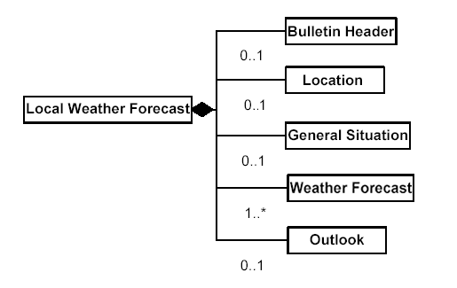

        - Child Elements
Name | BulletinHeader
Definition | Bulletin header of a Local Weather Forecast bulletin.
Type | BulletinHeader. Type
Occurrence | 0-1

Name | Location
Definition | Identification of a place for which the Local Weather Forecast bulletin is issued.
Type | Location. Type
Occurrence | 0-1

Name | GeneralSituation
Definition | Statement describing the general weather situation of the local area.
Type | Text. Type
Occurrence | 0-1 | Max. Length | 700

Name | WeatherForecast
Definition | Information on the weather predicted for the local area.
Type | WeatherForecast. Type
Occurrence | 1-*

Name | Outlook
Definition | Statement describing the weather outlook for the local area.
Type | Text. Type
Occurrence | 0-1 | Max. Length | 700

        - Example
<?xml version="1.0" encoding="UTF-8"?>
<LocalWeatherForecast xmlns:xsi="http://www.w3.org/2001/XMLSchema-instance" xsi:noNamespaceSchemaLocation="https://xml3.weather.gov.hk/V3/schemas/WXNML_iso-8859.xsd">
<BulletinHeader>
<BulletinName>Local Weather Forecast</BulletinName>
<BulletinType>F</BulletinType>
<BulletinProvider>Hong Kong Observatory</BulletinProvider>
<BulletinTime>2004-02-05T14:37:35+08:00</BulletinTime>
<Copyright>……</Copyright>
<Disclaimer>……/Disclaimer>
<Remarks>……</Remarks>
</BulletinHeader>
<GeneralSituation>The winter monsoon continues to bring cold weather to southern China.</GeneralSituation>
<WeatherForecast>
<ValidTime>
<Description>this afternoon and tonight</Description>
</ValidTime>
<WeatherDescription>It will be cold. Cloudy with rain patches. Moderate north to northeasterly winds, occasionally fresh over offshore waters.</WeatherDescription>
<WeatherIcon>
<URL>http://www.weather.gov.hk/images/wxicon/pic63.png</URL>
<Code>RN</Code>
</WeatherIcon>
</WeatherForecast>
<Outlook>Cold and rainy in the next few days.</Outlook>
</LocalWeatherForecast>

      - City Weather Forecast
Root | CityWeatherForecast
Name | CityWeatherForecast. Type
Definition | Predicted weather for city.
Structure | 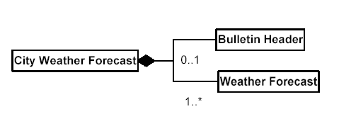

        - Child Elements
Name | BulletinHeader
Definition | Bulletin header of a City Weather Forecast bulletin.
Type | BulletinHeader. Type
Occurrence | 0-1

Name | WeatherForecast
Definition | Information on predicted weather for the city/cities.
Type | WeatherForecast. Type
Occurrence | 1-*

        - Example
<?xml version="1.0" encoding="UTF-8"?>
<CityWeatherForecast xmlns:xsi="http://www.w3.org/2001/XMLSchema-instance" xsi:noNamespaceSchemaLocation="https://xml3.weather.gov.hk/V3/schemas/WXNML_iso-8859.xsd">
<BulletinHeader>
<BulletinName> Weather of Cities in China</BulletinName>
<BulletinType>F</BulletinType>
<BulletinProvider>Hong Kong Observatory</BulletinProvider>
<BulletinTime>2004-02-04T21:50:20+08:00</BulletinTime>
<Copyright>……</Copyright>
<Disclaimer>……</Disclaimer>
<Remarks>……</Remarks>
</BulletinHeader>
<WeatherForecast>
<IssueTime>2004-02-04T22:00:00+08:00</IssueTime>
<InformationSource>
<CenterName>CMA</CenterName>
</InformationSource>
<Location>
<City>GUANGZHOU</City>
</Location>
<WeatherDescription>RAIN</WeatherDescription>
<TemperatureInformation>
<Medium>A</Medium>
<Type>N</Type>
<Reading>
<Measure unitCode="ZZ">5</Measure>
<UnitCode>CEL</UnitCode>
</Reading>
</TemperatureInformation>
<TemperatureInformation>
<Medium>A</Medium>
<Type>X</Type>
<Reading>
<Measure unitCode="ZZ">8</Measure>
<UnitCode>CEL</UnitCode>
</Reading>
</TemperatureInformation>
</WeatherForecast>
<WeatherForecast>……</WeatherForecast>
<WeatherForecast>……</WeatherForecast>
</CityWeatherForecast>

      - UV Index Forecast
Root | UVIndexForecast
Name | UVIndex. Type
Definition | Predicted UV Index.
Structure | 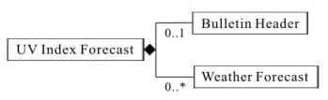

        - Child Elements
Name | BulletinHeader
Definition | Bulletin header of a UV Index Forecast bulletin.
Type | BulletinHeader. Type
Occurrence | 0-1

Name | WeatherForecast
Definition | Information on predicted UV Index.
Type | WeatherForecast. Type
Occurrence | 0-*

        - Example
<?xml version="1.0" encoding="UTF-8"?>
<UVIndexForecast xmlns:xsi="http://www.w3.org/2001/XMLSchema-instance" xsi:noNamespaceSchemaLocation="https://xml3.weather.gov.hk/V3/schemas/WXNML_iso-8859.xsd">
<BulletinHeader>
<BulletinName> UV Index Forecast </BulletinName>
<BulletinType>F</BulletinType>
<BulletinProvider>Hong Kong Observatory</BulletinProvider>
<BulletinTime>2006-05-14T22:25:09+08:00</BulletinTime>
<Copyright>……</Copyright>
<Disclaimer>……</Disclaimer>
<Remarks>……</Remarks>
</BulletinHeader>
<WeatherForecast>
<ValidTime>
<TimeWeekday>1</TimeWeekday>
<Description>15 MAY</Description>
</ValidTime>
<UltravioletInformation>
<Type>X</Type>
<Index>11</Index>
<Description> THE HONG KONG OBSERVATORY ADVISES THAT DIRECT EXPOSURE OF THE SKIN AND THE EYES TO SUNLIGHT SHOULD BE KEPT TO A MINIMUM AND PROLONGED EXPOSURE UNDER THE SUN SHOULD ALSO BE AVOIDED.</Description>
</UltravioletInformation>
</WeatherForecast>
</UVIndexForecast>

    - Weather Report
      - Current Weather
Root | CurrentWeather
Name | CurrentWeather. Type
Definition | Information on the current weather situation recorded.
Structure | 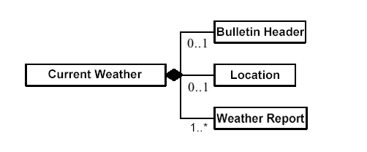

        - Child Elements
Name | BulletinHeader
Definition | Bulletin header of a Current Weather bulletin.
Type | BulletinHeader. Type
Occurrence | 0-1

Name | Location
Definition | Identification of a place for which the Current Weather bulletin is issued.
Type | Location. Type
Occurrence | 0-1

Name | SpecialAnnouncement
Definition | Special Announcement
Type | SpecialAnnouncement. Type
Occurrence | 0-1

Name | SpecialWeatherTip
Definition | Special Weather Tip
Type | SpecialWeather. Type
Occurrence | 0-*

Name | WarningInfo
Definition | Warning Information
Type | WarningInfo. Type
Occurrence | 0-*

Name | TropicalCycloneInfo
Definition | Tropical Cyclone Information
Type | TropicalCycloneInfo. Type
Occurrence | 0-*

Name | LightningInfo
Definition | Lightning Information
Type | LightningInfo. Type
Occurrence | 0-*

Name | WeatherReport
Definition | Information on recorded current weather.
Type | WeatherReport. Type
Occurrence | 1-*

        - Example
<?xml version="1.0" encoding="UTF-8"?>
<CurrentWeather xmlns:xsi="http://www.w3.org/2001/XMLSchema-instance" xsi:noNamespaceSchemaLocation="https://xml3.weather.gov.hk/V3/schemas/WXNML_iso-8859.xsd">
<BulletinHeader>
<BulletinName>Current Weather</BulletinName>
<BulletinType>R</BulletinType>
<BulletinProvider>Hong Kong Observatory</BulletinProvider>
<BulletinTime>2004-02-05T14:27:02+08:00</BulletinTime>
<Copyright>……</Copyright>
<Disclaimer>……</Disclaimer>
<Remarks>……</Remarks>
</BulletinHeader>
<WeatherReport>
<RecordTime>
<StartTime>2004-02-05T12:00:00+08:00</StartTime>
<EndTime>2004-02-05T12:00:00+08:00</EndTime>
</RecordTime>
<Location>
<Area>HONG KONG OBSERVATORY</Area>
</Location>
<TemperatureInformation>
<Medium>A</Medium>
<Type>I</Type>
<Reading>
<Measure unitCode="ZZ">9</Measure>
<UnitCode>CEL</UnitCode>
</Reading>
</TemperatureInformation>
<RelativeHumidityInformation>
<Type>I</Type>
<Reading>
<Measure unitCode="ZZ">93</Measure>
<UnitCode>P1</UnitCode>
</Reading>
</RelativeHumidityInformation>
</WeatherReport>
<WeatherReport>
<RecordTime>
<StartTime>2004-02-05T10:45:00+08:00</StartTime>
<EndTime>2004-02-05T11:45:00+08:00</EndTime>
</RecordTime>
<Location>
<Area>SAI KUNG</Area>
</Location>
<RainfallInformation>
<Type>X</Type>
<Reading>
<Measure unitCode="ZZ">1</Measure>
<UnitCode>MMT</UnitCode>
</Reading>
</RainfallInformation>
</WeatherReport>
</CurrentWeather>

      - Regional Weather
Root | RegionalWeather
Name | RegionalWeather. Type
Definition | Information on the weather situation recorded in different regions.
Structure | 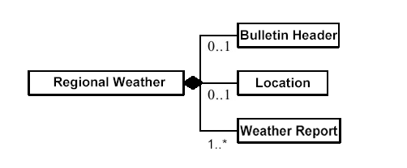

        - Child Elements
Name | BulletinHeader
Definition | Bulletin header of a Regional Weather bulletin.
Type | BulletinHeader. Type
Occurrence | 0-1

Name | Location
Definition | Identification of a place for which the Regional Weather bulletin is issued.
Type | Location. Type
Occurrence | 0-1

Name | WeatherReport
Definition | Information on recorded weather in the region(s).
Type | WeatherReport. Type
Occurrence | 1-*

        - Example
<?xml version="1.0" encoding="UTF-8"?>
<RegionalWeather xmlns:xsi="http://www.w3.org/2001/XMLSchema-instance" xsi:noNamespaceSchemaLocation="https://xml3.weather.gov.hk/V3/schemas/WXNML_iso-8859.xsd">
<BulletinHeader>
<BulletinName>Regional Weather In Hong Kong</BulletinName>
<BulletinType>R</BulletinType>
<BulletinProvider>Hong Kong Observatory</BulletinProvider>
<BulletinTime>2004-02-05T14:34:25+08:00</BulletinTime>
<Copyright>……</Copyright>
<Disclaimer>……</Disclaimer>
<Remarks>……</Remarks>
</BulletinHeader>
<WeatherReport>
<RecordTime>
<StartTime>2004-02-05T14:20:00+08:00</StartTime>
<EndTime>2004-02-05T14:20:00+08:00</EndTime>
</RecordTime>
<Location>
<Area>Hong Kong Observatory</Area>
</Location>
<TemperatureInformation>
<Medium>A</Medium>
<Type>I</Type>
<Reading>
<Measure unitCode="ZZ">9.8</Measure>
<UnitCode>CEL</UnitCode>
</Reading>
</TemperatureInformation>
<RelativeHumidityInformation>
<Type>I</Type>
<Reading>
<Measure unitCode="ZZ">89</Measure>
<UnitCode>P1</UnitCode>
</Reading>
</RelativeHumidityInformation>
<PressureInformation>
<AltitudeInformation>
<Altitude>
<Measure unitCode="ZZ">0</Measure>
<UnitCode>MTR</UnitCode>
</Altitude>
<ReferencePoint>S</ReferencePoint>
</AltitudeInformation>
<Type>I</Type>
<Reading>
<Measure unitCode="ZZ">1022.1</Measure>
<UnitCode>A97</UnitCode>
</Reading>
</PressureInformation>
</WeatherReport>
<WeatherReport>
<RecordTime>
<StartTime>2004-02-05T14:20:00+08:00</StartTime>
<EndTime>2004-02-05T14:20:00+08:00</EndTime>
</RecordTime>
<Location>
<Area>Wong Chuk Hang</Area>
</Location>
<TemperatureInformation>
<Medium>A</Medium>
<Type>I</Type>
<Reading>
<Measure unitCode="ZZ">10.5</Measure>
<UnitCode>CEL</UnitCode>
</Reading>
</TemperatureInformation>
<RelativeHumidityInformation>
<Type>I</Type>
<Reading>
<Measure unitCode="ZZ">84</Measure>
<UnitCode>P1</UnitCode>
</Reading>
</RelativeHumidityInformation>
</WeatherReport>
</RegionalWeather>

      - Yesterday Weather
Root | YesterdayWeather
Name | YesterdayWeather. Type
Definition | Information on the weather situation recorded yesterday.
Structure | 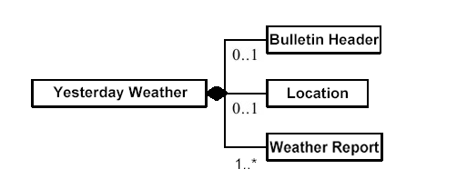

        - Child Elements
Name | BulletinHeader
Definition | Bulletin header of a Yesterday Weather bulletin.
Type | BulletinHeader. Type
Occurrence | 0-1

Name | Location
Definition | Identification of a place for which the Yesterday Weather bulletin is issued.
Type | Location. Type
Occurrence | 0-1

Name | WeatherReport
Definition | Information on recorded weather of yesterday.
Type | WeatherReport. Type
Occurrence | 1-*

        - Example
<?xml version="1.0" encoding="UTF-8"?>
<YesterdayWeather xmlns:xsi="http://www.w3.org/2001/XMLSchema-instance" xsi:noNamespaceSchemaLocation="https://xml3.weather.gov.hk/V3/schemas/WXNML_iso-8859.xsd">
<BulletinHeader>
<BulletinName>Yesterday's Weather </BulletinName>
<BulletinType>R</BulletinType>
<BulletinProvider>Hong Kong Observatory</BulletinProvider>
<BulletinTime>2004-02-18T00:15:22+08:00</BulletinTime>
<Copyright>……</Copyright>
<Disclaimer>……</Disclaimer>
<Remarks>……</Remarks>
</BulletinHeader>
<WeatherReport>
<RecordTime>
<StartTime>2004-02-17T00:00:00+08:00</StartTime>
<EndTime>2004-02-18T00:00:00+08:00</EndTime>
</RecordTime>
<Location>
<Area>HONG KONG OBSERVATORY</Area>
</Location>
<TemperatureInformation>
<Medium>A</Medium>
<Type>N</Type>
<Reading>
<Measure unitCode="ZZ">17.9</Measure>
<UnitCode>CEL</UnitCode>
</Reading>
</TemperatureInformation>
<TemperatureInformation>
<Medium>A</Medium>
<Type>X</Type>
<Reading>
<Measure unitCode="ZZ">23.1</Measure>
<UnitCode>CEL</UnitCode>
</Reading>
</TemperatureInformation>
<TemperatureInformation>
<Medium>G</Medium>
<Type>N</Type>
<Reading>
<Measure unitCode="ZZ">14.6</Measure>
<UnitCode>CEL</UnitCode>
</Reading>
</TemperatureInformation>
<RelativeHumidityInformation>
<Type>N</Type>
<Reading>
<Measure unitCode="ZZ">63</Measure>
<UnitCode>P1</UnitCode>
</Reading>
</RelativeHumidityInformation>
<RelativeHumidityInformation>
<Type>X</Type>
<Reading>
<Measure unitCode="ZZ">85</Measure>
<UnitCode>P1</UnitCode>
</Reading>
</RelativeHumidityInformation>
<RainfallInformation>
<Type>T</Type>
<Reading>
<Measure unitCode="ZZ">0</Measure>
<UnitCode>MMT</UnitCode>
</Reading>
</RainfallInformation>
</WeatherReport>
<WeatherReport>
<RecordTime>
<StartTime>2004-02-17T00:00:00+08:00</StartTime>
<EndTime>2004-02-18T00:00:00+08:00</EndTime>
</RecordTime>
<Location>
<Area>WONG CHUK HANG</Area>
</Location>
<TemperatureInformation>
<Medium>A</Medium>
<Type>N</Type>
<Reading>
<Measure unitCode="ZZ">17.1</Measure>
<UnitCode>CEL</UnitCode>
</Reading>
</TemperatureInformation>
<TemperatureInformation>
<Medium>A</Medium>
<Type>X</Type>
<Reading>
<Measure unitCode="ZZ">23.8</Measure>
<UnitCode>CEL</UnitCode>
</Reading>
</TemperatureInformation>
</WeatherReport>
</YesterdayWeather>
      - South China Coastal Waters
Root | SouthChinaCoastalWaters
Name | SouthChinaCoastalWaters. Type
Definition | Weather information, including general weather situation, weather forecast and weather report, at the South China coastal waters.
Structure | 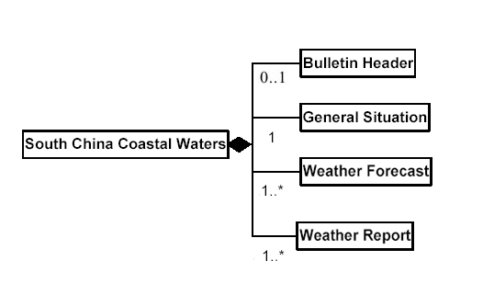

        - Child Elements
Name | BulletinHeader
Definition | Bulletin header of a South China Coastal Waters bulletin.
Type | BulletinHeader. Type
Occurrence | 0-1

Name | GeneralSituation
Definition | Statement describing the general weather situation at the South China coastal waters.
Type | Text. Type
Occurrence | 1 | Max. Length | 700

Name | WeatherForecast
Definition | Information on predicted weather for the South China coastal waters.
Type | WeatherForecast. Type
Occurrence | 1-*

Name | WeatherReport
Definition | Information on recorded weather at the South China coastal waters.
Type | WeatherReport. Type
Occurrence | 1-*

        - Example
<?xml version="1.0" encoding="UTF-8"?>
<SouthChinaCoastalWaters xmlns:xsi="http://www.w3.org/2001/XMLSchema-instance" xsi:noNamespaceSchemaLocation="https://xml3.weather.gov.hk/V3/schemas/WXNML_iso-8859.xsd">
<BulletinHeader>
<BulletinName>South China Coastal Waters</BulletinName>
<BulletinType>F</BulletinType>
<BulletinProvider>Hong Kong Observatory</BulletinProvider>
<BulletinTime>2004-02-05T12:30:15+08:00</BulletinTime>
<Copyright>……</Copyright>
<Disclaimer>……</Disclaimer>
<Remarks>……</Remarks>
</BulletinHeader>
<GeneralSituation>AN INTENSE NORTHEAST MONSOON IS AFFECTING THE SOUTH CHINA COASTAL WATERS.</GeneralSituation>
<WeatherForecast>
<ValidTime>
<Description>NEXT 24 HOURS</Description>
</ValidTime>
<Location>
<Area>HONG KONG ADJACENT WATERS</Area>
</Location>
<WeatherDescription>A FEW RAIN PATCHES</WeatherDescription>
<WindInformation>
<Type>M</Type>
<Description>NORTH TO NORTHEAST FORCE 5</Description>
</WindInformation>
<SeaSituationInformation>
<Description>MODERATE TO ROUGH SEAS</Description>
</SeaSituationInformation>
</WeatherForecast>
<WeatherForecast>……</WeatherForecast>
<WeatherForecast>……</WeatherForecast>
<WeatherReport>
<RecordTime>
<Description>LATEST</Description>
</RecordTime>
<Location>
<Area>WAGLAN ISLAND</Area>
</Location>
<WindInformation>
<Type>M</Type>
<Description>NORTH FORCE 4</Description>
</WindInformation>
<VisibilityInformation>
<Description>OVER 10 KILOMETRES</Description>
</VisibilityInformation>
</WeatherReport>
<WeatherReport>……</WeatherReport>
<WeatherReport>……</WeatherReport>
</SouthChinaCoastalWaters>

      - Hong Kong Waters
Root | HongKongWaters
Name | HongKongWaters. Type
Definition | Weather information, including weather forecast and/or weather report, at the Hong Kong waters. It may also include related astronomical information.
Structure | 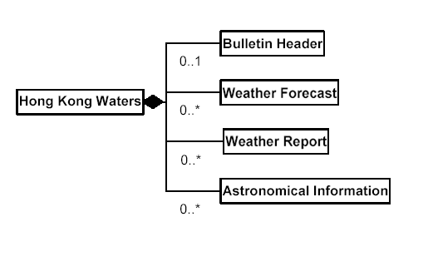

        - Child Elements
Name | BulletinHeader
Definition | Bulletin header of a Hong Kong Waters bulletin.
Type | BulletinHeader. Type
Occurrence | 0-1

Name | WeatherForecast
Definition | Information on predicted weather for the Hong Kong waters.
Type | WeatherForecast. Type
Occurrence | 0-*

Name | WeatherReport
Definition | Information on recorded weather at the Hong Kong waters.
Type | WeatherReport. Type
Occurrence | 0-*

Name | AstronomicalInformation
Definition | Information related to astronomy at the Hong Kong waters.
Type | AstronomicalInformation. Type
Occurrence | 0-*

        - Example
<?xml version="1.0" encoding="UTF-8"?>
<HongKongWaters xmlns:xsi="http://www.w3.org/2001/XMLSchema-instance" xsi:noNamespaceSchemaLocation="https://xml3.weather.gov.hk/V3/schemas/WXNML_iso-8859.xsd">
<BulletinHeader>
<BulletinName>Hong Kong Waters</BulletinName>
<BulletinType>F</BulletinType>
<BulletinProvider>Hong Kong Observatory</BulletinProvider>
<BulletinTime>2004-02-15T08:15:12+08:00</BulletinTime>
<Copyright>……</Copyright>
<Disclaimer>……</Disclaimer>
<Remarks>……</Remarks>
</BulletinHeader>
<WeatherForecast>
<ValidTime>
<Description>NEXT 12 HOURS</Description>
</ValidTime>
<Location>
<Area>WAGLAN ISLAND</Area>
</Location>
<SeaWaveInformation>
<Type>N</Type>
<Height>
<Measure unitCode="ZZ">1.5</Measure>
<UnitCode>MTR</UnitCode>
</Height>
</SeaWaveInformation>
<SeaWaveInformation>
<Type>X</Type>
<Height>
<Measure unitCode="ZZ">2</Measure>
<UnitCode>MTR</UnitCode>
</Height>
</SeaWaveInformation>
</WeatherForecast>
<WeatherReport>
<RecordTime>
<StartTime>2004-02-15T08:00:00+08:00</StartTime>
<EndTime>2004-02-15T08:00:00+08:00</EndTime>
</RecordTime>
<Location>
<Area>WAGLAN ISLAND</Area>
</Location>
<WindInformation>
<Type>I</Type>
<Description>EAST-NORTHEAST FORCE 6</Description>
</WindInformation>
<VisibilityInformation>
<Description>OVER 10 KILOMETRES</Description>
</VisibilityInformation>
</WeatherReport>
<AstronomicalInformation>
<Location>
<Area>VICTORIA HARBOUR</Area>
</Location>
<PredictedTidalInformation>
<Type>H</Type>
<OccurrenceTime>2004-02-15T16:28:00+08:00</OccurrenceTime>
<Height>
<Measure unitCode="ZZ">2.1</Measure>
<UnitCode>MTR</UnitCode>
</Height>
</PredictedTidalInformation>
</AstronomicalInformation>
<AstronomicalInformation>
<Location>
<Area>VICTORIA HARBOUR</Area>
</Location>
<PredictedTidalInformation>
<Type>L</Type>
<OccurrenceTime>2004-02-16T00:58:00+08:00</OccurrenceTime>
<Height>
<Measure unitCode="ZZ">0.7</Measure>
<UnitCode>MTR</UnitCode>
</Height>
</PredictedTidalInformation>
</AstronomicalInformation>
</HongKongWaters>

      - Tropical Cyclone Bulletin
Root | TropicalCycloneBulletin
Name | TropicalCycloneBulletin. Type
Definition | Information related to tropical cyclone.
Structure | 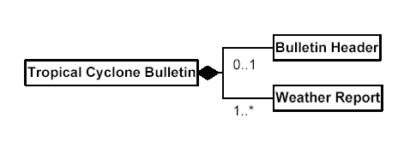

        - Child Elements
Name | BulletinHeader
Definition | Bulletin header of a Tropical Cyclone bulletin.
Type | BulletinHeader. Type
Occurrence | 0-1

Name | WeatherReport
Definition | Information on recorded weather related to the tropical cyclone.
Type | WeatherReport. Type
Occurrence | 1-*

        - Example
<?xml version="1.0" encoding="UTF-8"?>
<TropicalCycloneBulletin xmlns:xsi="http://www.w3.org/2001/XMLSchema-instance" xsi:noNamespaceSchemaLocation="https://xml3.weather.gov.hk/V3/schemas/WXNML_iso-8859.xsd">
<BulletinHeader>
<BulletinName>Tropical Cyclone Bulletin</BulletinName>
<BulletinType>R</BulletinType>
<BulletinProvider>Hong Kong Observatory</BulletinProvider>
<BulletinTime>2004-02-09T15:26:10+08:00</BulletinTime>
<Copyright>……</Copyright>
<Disclaimer>……</Disclaimer>
<Remarks>……</Remarks>
</BulletinHeader>
<WeatherReport>
<RecordTime>
<StartTime>2004-02-08T23:00:00+08:00</StartTime>
<EndTime>2004-02-08T23:00:00+08:00</EndTime>
</RecordTime>
<TropicalCycloneInformation>
<Name>TROPICAL STORM MELOR</Name>
<Latitude>23.7N</Latitude>
<Longitude>123.6E</Longitude>
<Description>AT 11 P.M. LAST NIGHT THE CENTRE OF TROPICAL STORM MELOR WAS NEAR 23.7 DEGREES NORTH 123.6 DEGREES EAST.</Description>
</TropicalCycloneInformation>
</WeatherReport>
</TropicalCycloneBulletin>

    - Weather Announcement and Warning

      - Weather Announcement Bulletin
Root | WeatherAnnouncementBulletin
Name | WeatherAnnouncementBulletin. Type
Definition | Bulletin with information on announcement issued due to special weather situation.
Structure | 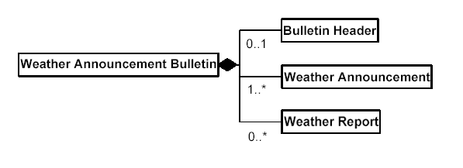

        - Child Elements
Name | BulletinHeader
Definition | Bulletin header of a Weather Announcement bulletin.
Type | BulletinHeader. Type
Occurrence | 0-1

Name | WeatherAnnouncement
Definition | Detailed information of the weather announcement.
Type | WeatherAnnouncement. Type
Occurrence | 1-*

Name | WeatherReport
Definition | Information on recorded weather related to the weather announcement.
Type | WeatherReport. Type
Occurrence | 0-*

        - Example
<?xml version="1.0" encoding="UTF-8"?>
<WeatherAnnouncementBulletin xmlns:xsi="http://www.w3.org/2001/XMLSchema-instance" xsi:noNamespaceSchemaLocation="https://xml3.weather.gov.hk/V3/schemas/WXNML_iso-8859.xsd">
<BulletinHeader>
<BulletinName>Special Announcement On Flooding In Northern New Territories</BulletinName>
<BulletinType>A</BulletinType>
<BulletinProvider>Hong Kong Observatory</BulletinProvider>
<BulletinTime>2003-06-11T00:27:51+08:00</BulletinTime>
<Copyright>……</Copyright>
<Disclaimer>……</Disclaimer>
<Remarks>……</Remarks>
</BulletinHeader>
<WeatherAnnouncement>
<Name>Special Announcement On Flooding In Northern NT</Name>
<IssueTime>2003-06-11T00:01:00+08:00</IssueTime>
<InForce>1</InForce>
<Action>I</Action>
<Description>SPECIAL ANNOUNCEMENT ON FLOODING IN THE NORTHERN NEW TERRITORIES ISSUED BY THE HONG KONG OBSERVATORY AT 0:01 A.M. ON 11 JUN : HEAVY RAIN IS AFFECTING THE NORTHERN PART OF THE NEW TERRITORIES, ESPECIALLY IN YUEN LONG/KAM TIN/SAN TIN AREAS. MORE THAN 60 MILLIMETRES OF RAINFALL HAVE BEEN RECORDED THERE IN THE PAST HOUR. RESIDENTS IN THE NORTHERN NEW TERRITORIES, WHO ARE LIKELY TO BE AFFECTED, ARE ADVISED TO TAKE NECESSARY PRECAUTIONS TO AVOID POSSIBLE FLOOD DAMAGE. THEY SHOULD ALSO PAY ATTENTION TO THE FLOOD SIRENS IF THEY ARE NEARBY.</Description>
</WeatherAnnouncement>
</WeatherAnnouncementBulletin>

      - Weather Warning Bulletin
Root | WeatherWarningBulletin
Name | WeatherWarningBulletin. Type
Definition | Bulletin with information on warning issued due to special weather situation.
Structure | 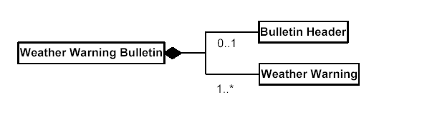

        - Child Elements
Name | BulletinHeader
Definition | Bulletin header of a Weather Warning bulletin.
Type | BulletinHeader. Type
Occurrence | 0-1

Name | WeatherWarning
Definition | Detailed information of the weather warning.
Type | WeatherWarning. Type
Occurrence | 1-*

        - Example
<?xml version="1.0" encoding="UTF-8"?>
<WeatherWarningBulletin xmlns:xsi="http://www.w3.org/2001/XMLSchema-instance" xsi:noNamespaceSchemaLocation="https://xml3.weather.gov.hk/V3/schemas/WXNML_iso-8859.xsd">
<BulletinHeader>
<BulletinName>Tropical Cyclone Warning Signal</BulletinName>
<BulletinType>W</BulletinType>
<BulletinProvider>Hong Kong Observatory</BulletinProvider>
<BulletinTime>2002-09-11T05:41:12+08:00</BulletinTime>
<Copyright>……</Copyright>
<Disclaimer>……</Disclaimer>
<Remarks>……</Remarks>
</BulletinHeader>
<WeatherWarning>
<Name>Tropical Cyclone Warning Signal</Name>
<Type>Strong Wind Signal No. 3</Type>
<IssueTime>2002-09-11T05:40:00+08:00</IssueTime>
<InForce>1</InForce>
<Action>I</Action>
<Description>THE STRONG WIND SIGNAL, NO. 3, WAS ISSUED AT 5:40 A.M.</Description>
</WeatherWarning>
</WeatherWarningBulletin>

      - Weather Warning Summary
Root | WeatherWarningSummary
Name | WeatherWarningSummary. Type
Definition | Summary of the status of the weather warning(s).
Structure | 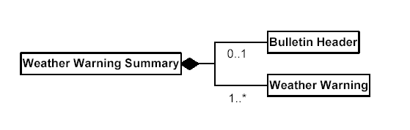

        - Child Elements
Name | BulletinHeader
Definition | Bulletin header of a Weather Warning Summary bulletin.
Type | BulletinHeader. Type
Occurrence | 0-1

Name | WeatherWarning
Definition | Detailed information on the weather warning(s).
Type | WeatherWarning. Type
Occurrence | 1-*

        - Example
<?xml version="1.0" encoding="UTF-8"?>
<WeatherWarningSummary xmlns:xsi="http://www.w3.org/2001/XMLSchema-instance" xsi:noNamespaceSchemaLocation="https://xml3.weather.gov.hk/V3/schemas/WXNML_iso-8859.xsd">
<BulletinHeader>
<BulletinName>Weather Warning Summary</BulletinName>
<BulletinType>W</BulletinType>
<BulletinProvider>Hong Kong Observatory</BulletinProvider>
<BulletinTime>2004-01-28T19:29:03+08:00</BulletinTime>
<Copyright>……</Copyright>
<Disclaimer>……</Disclaimer>
<Remarks>……</Remarks>
</BulletinHeader>
<WeatherWarning>
<Name>Tropical Cyclone Warning Signal</Name>
<InForce>0</InForce>
<Description>THERE IS NO WARNING IN FORCE.</Description>
</WeatherWarning>
<WeatherWarning>
<Name>Cold Weather Warning</Name>
<IssueTime>2004-01-27T23:15:00+08:00</IssueTime>
<InForce>1</InForce>
</WeatherWarning>
</WeatherWarningSummary>

    - Astronomical Information
      - Astronomical Information Bulletin
Root | AstronomicalInformationBulletin
Name | AstronomicalInformationBulletin. Type
Definition | Information related to astronomy.
Structure | 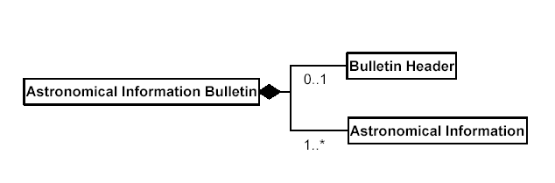

        - Child Elements
Name | BulletinHeader
Definition | Bulletin header of an Astronomical Information bulletin.
Type | BulletinHeader. Type
Occurrence | 0-1

Name | AstronomicalInformation
Definition | Detailed information on astronomy.
Type | AstronomicalInformation. Type
Occurrence | 1-*

        - Example
<?xml version="1.0" encoding="UTF-8"?>
<AstronomicalInformationBulletin xmlns:xsi="http://www.w3.org/2001/XMLSchema-instance" xsi:noNamespaceSchemaLocation="https://xml3.weather.gov.hk/V3/schemas/WXNML_iso-8859.xsd">
<BulletinHeader>
<BulletinName>Astronomical Information</BulletinName>
<BulletinType>I</BulletinType>
<BulletinProvider>Hong Kong Observatory</BulletinProvider>
<BulletinTime>2004-03-07T21:30:09+08:00</BulletinTime>
<Copyright>……</Copyright>
<Disclaimer>……</Disclaimer>
<Remarks>……</Remarks>
</BulletinHeader>
<AstronomicalInformation>
<SolarLunarInformation>
<Type>SR</Type>
<OccurrenceTime>2004-03-08T06:39:00+08:00</OccurrenceTime>
</SolarLunarInformation>
<SolarLunarInformation>
<Type>SS</Type>
<OccurrenceTime>2004-03-08T18:30:00+08:00</OccurrenceTime>
</SolarLunarInformation>
<PredictedTidalInformation>
<Type>L</Type>
<OccurrenceTime>2004-03-08T04:30:00+08:00</OccurrenceTime>
<Height>
<Measure unitCode="ZZ">0.4</Measure>
<UnitCode>MTR</UnitCode>
</Height>
</PredictedTidalInformation>
<PredictedTidalInformation>
<Type>H</Type>
<OccurrenceTime>2004-03-08T10:41:00+08:00</OccurrenceTime>
<Height>
<Measure unitCode="ZZ">1.5</Measure>
<UnitCode>MTR</UnitCode>
</Height>
</PredictedTidalInformation>
</AstronomicalInformation>
</AstronomicalInformationBulletin>

    - Tsunami Warning and Information
      - Tsunami Information Bulletin
Root | TsunamiInformationBulletin
Name | TsunamiInformationBulletin. Type
Definition | Information related to tsunami.
Structure | 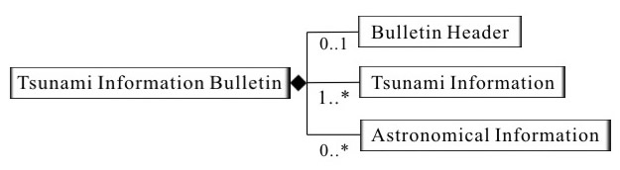

        - Child Elements
Name | BulletinHeader
Definition | Bulletin header of a Tsunami Information bulletin.
Type | BulletinHeader. Type
Occurrence | 0-1

Name | TsunamiInformation
Definition | Detailed information on tsunami.
Type | TsunamiInformation. Type
Occurrence | 1-*

Name | AstronomicalInformation
Definition | Detailed information on astronomy.
Type | AstronomicalInformation. Type
Occurrence | 0-*

        - Example
<?xml version="1.0" encoding="UTF-8"?>
<TsunamiInformationBulletin xmlns:xsi="http://www.w3.org/2001/XMLSchema-instance" xsi:noNamespaceSchemaLocation="https://xml3.weather.gov.hk/V3/schemas/WXNML_iso-8859.xsd">
<BulletinHeader>
<BulletinName>Tsunami Information</BulletinName>
<BulletinType>I</BulletinType>
<BulletinProvider>Hong Kong Observatory</BulletinProvider>
<BulletinTime>2005-12-30T03:11:06+08:00</BulletinTime>
<Copyright>……</Copyright>
<Disclaimer>……</Disclaimer>
<Remarks>……</Remarks>
</BulletinHeader>
<TsunamiInformation>
<IssueTime>2005-12-30T03:15:00+08:00</IssueTime>
<Description>Tsunami Information Bulletin issued by the Hong Kong Observatory at 3:15 a.m. on 30 December 2005. A severe earthquake of magnitude ___ occurred near ___ at about 3:00 a.m. on 30 December 2005. The earthquake is expected to generate a tsunami in the South China Sea. If the tsunami persists, it would reach Hong Kong around 4:05 a.m. and recur at intervals of 5 to 60 minutes. It is impossible to predict the precise height of the tsunami. The Observatory will closely monitor the situation.</Description>
<Description>Tsunami heights around the South China Sea : __________ </Description>
<Description>Precautionary announcement : 1. Please stay tuned to the radio or television for further information.</Description>
</TsunamiInformation>
<AstronomicalInformation>
<PredictedTidalInformation>
<Type>L</Type>
<OccurrenceTime>2005-12-30T03:10:00+08:00</OccurrenceTime>
<Height>
<Measure unitCode="ZZ">0.4</Measure>
<UnitCode>MTR</UnitCode>
</Height>
</PredictedTidalInformation>
<PredictedTidalInformation>
<Type>H</Type>
<OccurrenceTime>2005-12-30T10:19:00+08:00</OccurrenceTime>
<Height>
<Measure unitCode="ZZ">1.4</Measure>
<UnitCode>MTR</UnitCode>
</Height>
</PredictedTidalInformation>
<PredictedTidalInformation>
<Type>L</Type>
<OccurrenceTime>2005-12-30T13:08:00+08:00</OccurrenceTime>
<Height>
<Measure unitCode="ZZ">1.3</Measure>
<UnitCode>MTR</UnitCode>
</Height>
</PredictedTidalInformation>
<PredictedTidalInformation>
<Type>H</Type>
<OccurrenceTime>2005-12-30T19:43:00+08:00</OccurrenceTime>
<Height>
<Measure unitCode="ZZ">2.6</Measure>
<UnitCode>MTR</UnitCode>
</Height>
</PredictedTidalInformation>
</AstronomicalInformation>
</TsunamiInformationBulletin>

      - Tsunami Warning Bulletin
Root | TsunamiWarningBulletin
Name | TsunamiWarningBulletin. Type
Definition | Warning related to tsunami.
Structure | 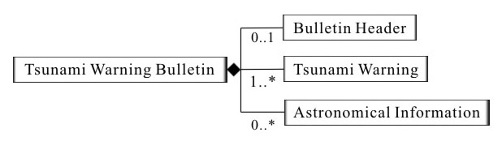

        - Child Elements
Name | BulletinHeader
Definition | Bulletin header of a Tsunami Warning bulletin.
Type | BulletinHeader. Type
Occurrence | 0-1

Name | TsunamiWarning
Definition | Detailed information on the tsunami warning.
Type | TsunamiWarning. Type
Occurrence | 1-*

Name | AstronomicalInformation
Definition | Detailed information on astronomy.
Type | AstronomicalInformation. Type
Occurrence | 0-*

        - Example
<?xml version="1.0" encoding="UTF-8"?>
<TsunamiWarningBulletin xmlns:xsi="http://www.w3.org/2001/XMLSchema-instance" xsi:noNamespaceSchemaLocation="https://xml3.weather.gov.hk/V3/schemas/WXNML_iso-8859.xsd">
<BulletinHeader>
<BulletinName>Tsunami Warning</BulletinName>
<BulletinType>W</BulletinType>
<BulletinProvider>Hong Kong Observatory</BulletinProvider>
<BulletinTime>2005-12-30T03:11:06+08:00</BulletinTime>
<Copyright>……</Copyright>
<Disclaimer>……</Disclaimer>
<Remarks>……</Remarks>
</BulletinHeader>
<TsunamiInformation>
<IssueTime>2005-12-30T03:15:00+08:00</IssueTime>
<InForce>1</InForce>
<Description>Tsunami Warning issued by the Hong Kong Observatory at 3:15 a.m. on 30 December 2005. A severe earthquake of magnitude ___ occurred near ___ at about 3:00 a.m. on 30 December 2005. The earthquake is expected to generate a tsunami in the South China Sea. If the tsunami persists, it would reach Hong Kong around 4:05 a.m. and recur at intervals of 5 to 60 minutes. It is impossible to predict the precise height of the tsunami but precautions should be taken for the sake of safety. </Description>
<Description>Tsunami heights around the South China Sea : __________ </Description>
<Description>Precautionary announcements : 1. Stay away from beaches and low-lying coastal areas. If you are there, move to high grounds or upper floors of a concrete building. 2. Do not engage in water sports. 3. Small vessels in deep waters should stay away from the shore or shallow waters. 4. Please observe these precautions until the Observatory issues the final tsunami warning bulletin for this event. 5. Please stay tuned to the radio or television for further information.</Description>
</TsunamiInformation>
<AstronomicalInformation>
<PredictedTidalInformation>
<Type>L</Type>
<OccurrenceTime>2005-12-30T03:10:00+08:00</OccurrenceTime>
<Height>
<Measure unitCode="ZZ">0.4</Measure>
<UnitCode>MTR</UnitCode>
</Height>
</PredictedTidalInformation>
<PredictedTidalInformation>
<Type>H</Type>
<OccurrenceTime>2005-12-30T10:19:00+08:00</OccurrenceTime>
<Height>
<Measure unitCode="ZZ">1.4</Measure>
<UnitCode>MTR</UnitCode>
</Height>
</PredictedTidalInformation>
<PredictedTidalInformation>
<Type>L</Type>
<OccurrenceTime>2005-12-30T13:08:00+08:00</OccurrenceTime>
<Height>
<Measure unitCode="ZZ">1.3</Measure>
<UnitCode>MTR</UnitCode>
</Height>
</PredictedTidalInformation>
<PredictedTidalInformation>
<Type>H</Type>
<OccurrenceTime>2005-12-30T19:43:00+08:00</OccurrenceTime>
<Height>
<Measure unitCode="ZZ">2.6</Measure>
<UnitCode>MTR</UnitCode>
</Height>
</PredictedTidalInformation>
</AstronomicalInformation>
</TsunamiWarningBulletin>

